Question 1a.

What type of evidence do Westall et al. (1999) propose as criterion for the identification of ancient bacterial activity, on Earth or on Mars (1a)?

(The text is posted on WebCT.)

Question 1b.

Examine the layered specimen collected from the Ediacara hills, in Australia (no sketch required). Its interpretation is tricky. Similar-looking rocks are sometimes described simply as "algal" rock.

Are the layered structures in this specimen, and in many stromatolites, examples of body fossils, trace fossils, or chemical fossils (1b)? Briefly justify your answer.

Question 1c.

Brian Jones (U. Alberta) has examined stromatolites and microbial structures forming in a wide range of Recent settings. The bacterial communities involved in the origin of these trace fossils were not necessarily prokaryotic blue-green algae.

What other type of organisms were involved in the formation of stromatolites described by Jones et al. (1997) (1c)?

Question 1d.

What conditions would stromatolites have to meet in order to be considered good index fossils for specific intervals of Precambrian time (1d)?
Question 2: Ediacara

Note the nature of the sedimentary rock in which Ediacaran impressions are preserved: is it limestone, shale or sandstone (2a)?

Considering the texture of the sedimentary rock in which many Ediacaran impressions are preserved, is it likely that these fossils were soft-bodied (justify briefly your answer)? (2b)

What role may bacterial mats have played in the preservation of Ediacaran organisms (2c)? The diagram below summarizes a scenario suggested by Gehling (1999).
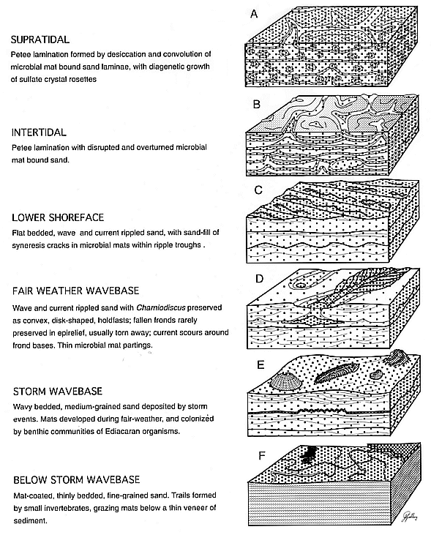
Question 2d.

Even where the sedimentary rock is much finer-grained, the impressions left by many Ediacaran fossils suggest "quilted" surface patterns. What did Seilacher mean by the term "quilted" (see e in Fig. 3.1 from Clarkson, 1999) when he proposed that Ediacaran animals shared a body plan radically different from that of any known living animal phylum (2d).

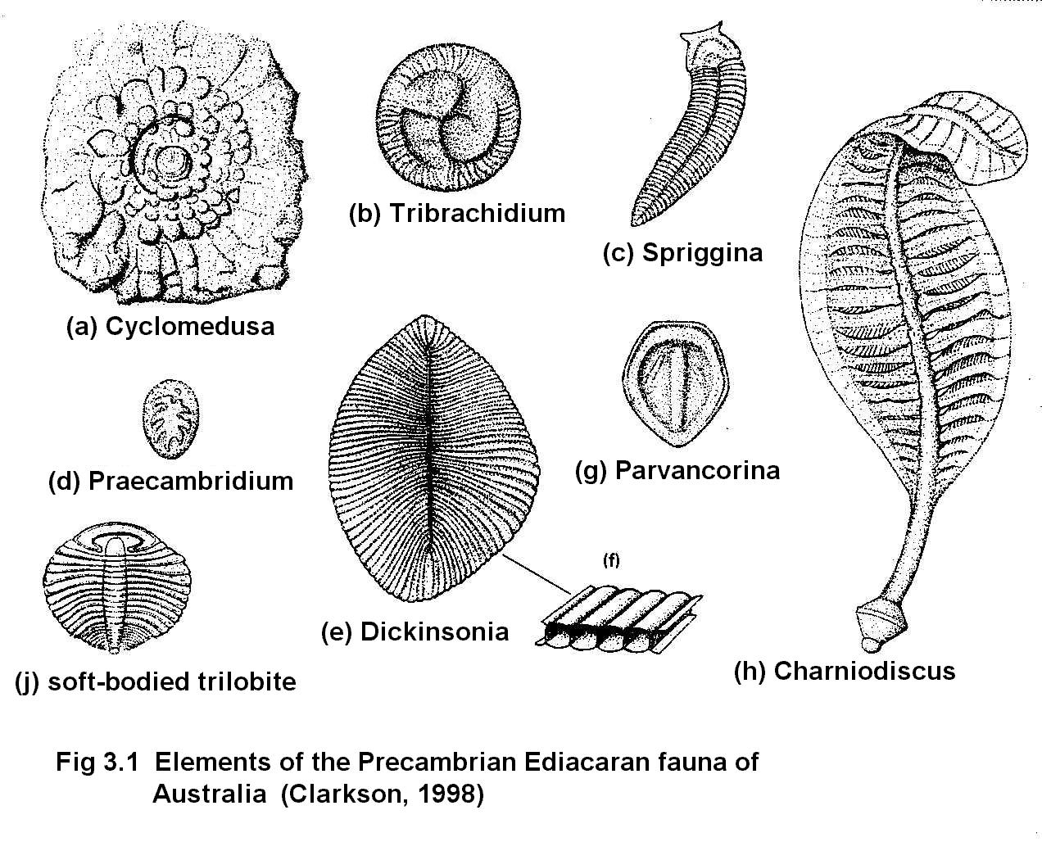
Question 3: Ediacara

Among these drawings of Ediacaran animals, can you find at least one example each of a radial and a bilateral body symmetry (3)?

Question 4:
Class DEMOSPONGIA

This class of sponges has a skeleton of spongin and/or siliceous spicules. The order KERATOSA, which does not have a fossil record, includes the familiar bath sponges (skeleton of spongin only).

Examine the specimens of modern dried spongin sponges. Choose one and examine its wall structure. Describe features that identify it as being of the leucon grade (4a).

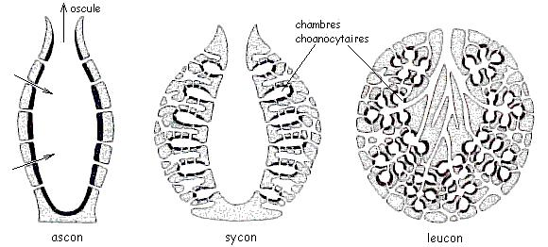
Draw the sponge, label its ostia and osculum (or oscula) and indicate with arrows the path of water in or out of them (4b). Is this poriferan body plan an example of radial or bilateral symmetry (4c)?

Draw the specimen you selected and label its ostia and osculum, so as to clearly explain what grade of organization you recognize in its canal system (4).
Question 5.

Tethya - Examine the specimens of this small spherical sponge from post-glacial clays of the Montreal area. Draw some of the spicules using the microscope (5). Do they seem hollow, or knobby for articulation?

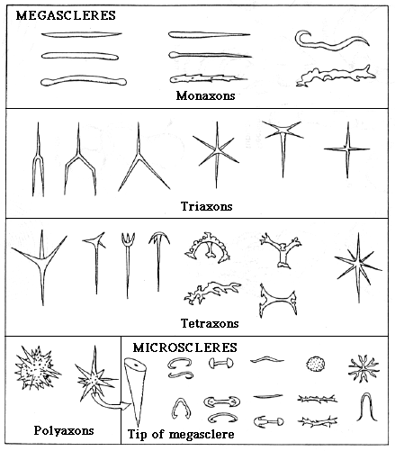
Question 6.

Examine the collection of flints collected from the Cretaceous Chalk of the English Channel. Note the sponge fossils. What was the likely origin of the mineral matter that hardened into flint (6)?
Question 7.

Examine and draw a sketch of the cross section of the Cretaceous lithistid Siphonia (7a). Draw small arrows to show the path of the water through the canals. Why isn't the larger osculum visible, on the vertical section cut through the specimen (7b)?

The canals are commonly filled with sediment or permineralized with CaCO₃ after death, making it hard to see them if the filling shows no strong colour difference with the skeleton. Use the diagram below (from Clarkson, Figure 4.6, p. 89). The incurrent canals, which bring water inside the sponge have the smaller openings called ostia. The larger opening, through which water is expelled after filtering for food particles, is the osculum.

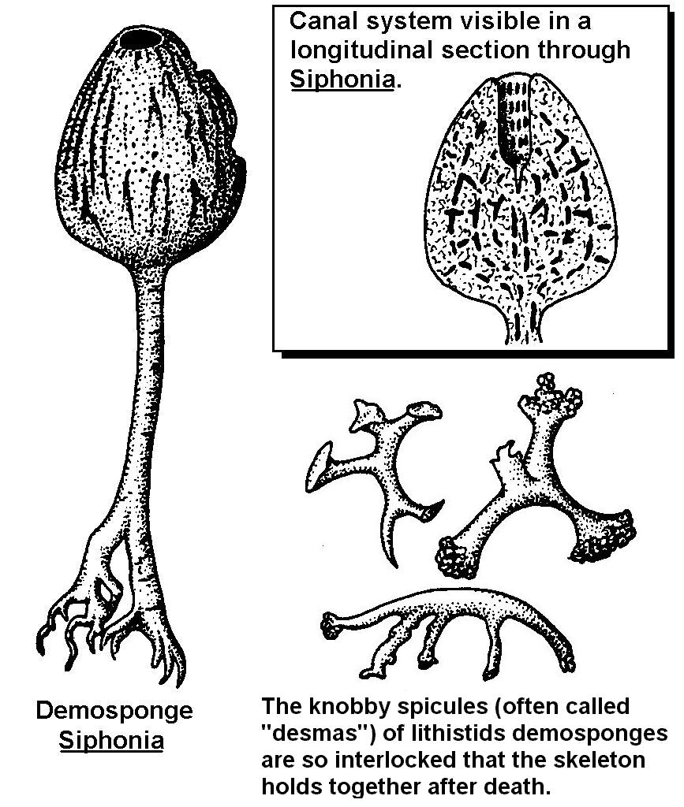

Note: Jerea is a fairly similar-looking lithistid genus. You can use it as an example of the intact Siphonia.
Question 8.

Astylospongia is a much older lithistid, found in the Silurian limestones of Ontario where they are associated with chert nodules. Examine the specimens and draw one of them (8a). Is there any evidence of the type of canal system or the grade (ascon, sycon, leucon) of this sponge (8b)?
Question 9.
CLASS Hexactinellida:
the "glass sponges"

Hydnoceras - Make a sketch of the specimen (9a). What form of spicule could give rise to the rectilinear network of its skeleton (9b)?
Observation only

CLASS Hexactinellida:
the "glass sponges"

Ventriculites is a sponge of very variable shape from the Cretaceous of Europe. Examine the specimens.

Can you distinguish spicules, as in the hexactinellid Hydnoceras (shown with question 9)? NO SKETCH or ANSWER REQUIRED.
Observation only

CLASS CALCAREA
(or calcisponges)

Girtycoelia is an example of a group of sponges called sphinctozoans which consist of a linear series of hollow, globular bodies with an axial tube. Until a specimen was recently found in the sea, sphinctozoans were thought to be extinct!

There are similarities between sphinctozoans and some archeocyathids, suggesting a possible biological relationship between the two groups.

Examine the specimen.
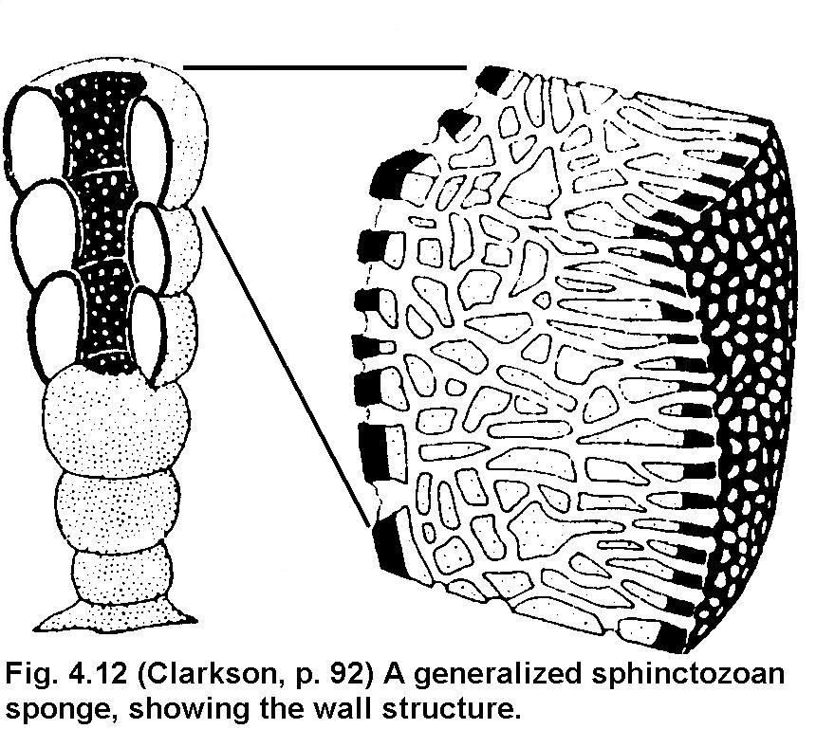
Question 10.

CLASS CALCAREA
(or calcisponges)

Astraeospongium is a saucer-shaped sponge common in the Middle Silurian of the United States. The spicules have 6 rays in one plane (forming a star) and two button-like rays at right angle to them.

Sketch a single spicule (10a) as well as the whole specimen (10b). (Use separate bar scales for the spicule and specimen, in order to show their relative sizes.)

Do you think the saucer was facing up or down during the life of the organism (10c) and why?
Question 11.

STROMATOPOROIDS
(extinct sclerosponges)

Examine the specimens of Silurian and Devonian periods. Labechia is an early Ordovician representative of the group. Examine the thin section (by holding it to the light) to see the pattern of laminae and pillars secreted by the organism.

The external growth forms of stromatolites and stromatoporoids can be very similar. So, how could you tell apart a stromatoporoid from a stromatolite (11)?

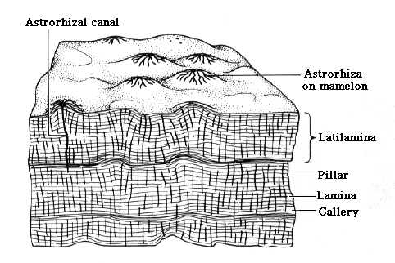
(Go back to question 1 if you need to look at stromatolites again.)
Question 12.

CLASS Archaeocyatha (extinct, probably poriferans)

Examine the small specimens of archeocyathids (filled with a reddish sedimentary rock) and the limestone containing some of their molds.

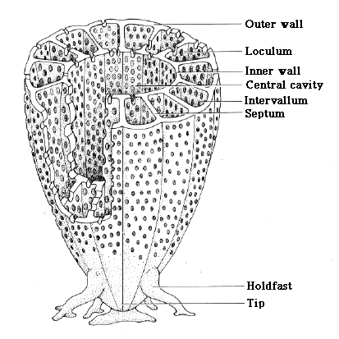
Sketch any one of the specimens to show the inner cavity, the two walls, and the radial partition (12a).

How do they compare, in size and structure, to the specimen of a Paleozoic solitary horn coral (12b)? Mention only features you can see on the specimens provided.

QUESTION 12c.

Would you infer, from your observations and their known timespan in the fossil record, that archeocyathids are good or poor index fossils for the early Cambrian (12c)?

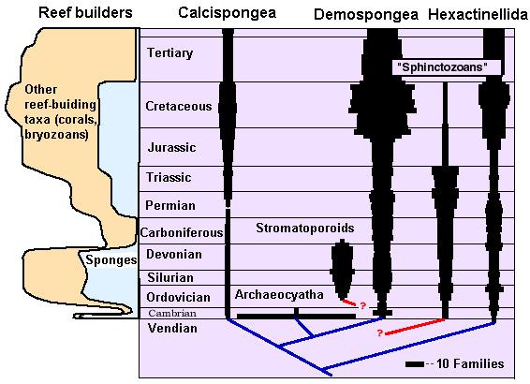
Question 13:

RECEPTACULITIDS

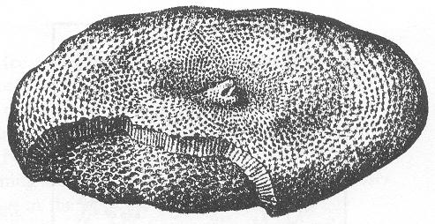
This group of enigmatic fossils are probably not sponges, as was sometimes thought, but primitive plants (dasyclads, a type of green calcareous algae).

Examine specimens of this fossil. How could it have been confused with a poriferan (13)?
Question 14:

RECEPTACULITIDS

These are a group of enigmatic fossils (i.e. of uncertain affinity) that are probably not sponges but primitive plants. Receptaculites is a common fossil in Ordovician limestones in Quebec and Manitoba. It is saucer-shaped and may be as large as a dinner plate.
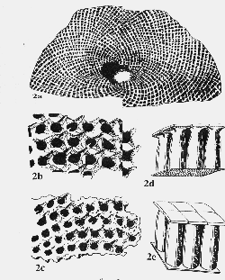

Examine specimens of this fossil. What features might have led scientists to interpret it as a poriferan (14)?

