McGill University
EPSC 334 Invertebrate Paleontology

LABORATORY EXERCISE # 8
CEPHALOPODS (phylum MOLLUSCA)

Typical living cephalopods include the squid, octopus, cuttlefish, and pearly nautilus. These animals have a head equipped with tentacles that bring food to the mouth. The mantle encloses a relatively large cavity that houses the gills and is connected to the water by a narrow opening called the funnel. Animals like the squid are capable of rapid movement backward by jetting water from the funnel, and slower swimming motions using a fin along the side of the body.

The single shells secreted by cephalopods consist of a series of chambers added as the animal grows. The modern Nautilus lives in the last chamber of its large shell and its soft parts are much like those of the squid. The septa that divide the shell into chambers represent successive positions of the back of the animal as it grows to a mature size, at which time it stops secreting the shell. The animal is in communication with the abandoned chambers by means of a thin strand of tissue in a tube (the siphuncle) leading through the septa. The tube consists of short backward extensions of the septa (septal necks) and connecting rings.
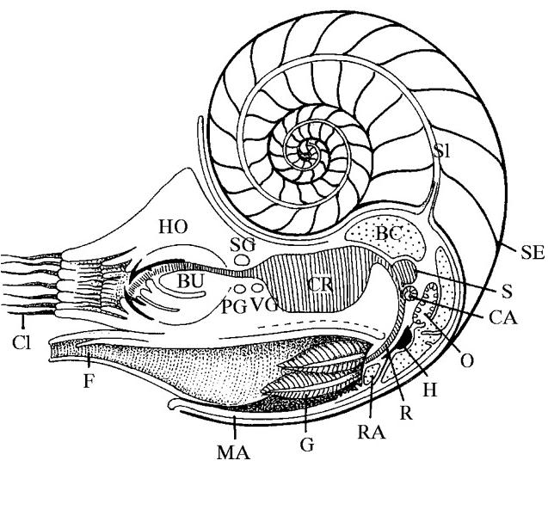
Nautilus shells

THESE ARE FRAGILE –
DO NOT DROP THEM!

Examine the shell fragments that show the interior and the polished specimen of a Recent or a fossilized coiled nautiloid. Orient the shell in its living position and draw a cross section through the plane of the siphuncle of the shell and label the following: septum (SE), septal neck, septal foramina, position of the siphuncle (SI: you may dot it in since the connecting rings are not preserved), living chamber, initial chamber (1).

Note the striped protective colouring on the exterior. The smaller specimens are immature (juvenile). How does the colour pattern change in the mature animal (2a)? What may be the adaptive value of the pattern (2b)? Why should it change as the animal matures (2c)?

The septa of nautiloids are simple concave plates. This is best seen in fossil specimens in which the chambers have been filled with sediment and then fell apart. Examine the specimen that shows these separated chambers.

The "pearly" aragonite inner layer of Nautilus is only visible where the dull outer layer has worn off. The outer layer is commonly removed from specimens sold in shops to enhance their appearance. Examine the specimen from which the outer layer has been stripped away. Was a similar layer present on the inside of some bivalves? Whas was its name and mineralogy (3)?

FOSSIL NAUTILOIDS

Many of the nautiloids of the Paleozoic were straight cones, not coiled like Nautilus but some were coiled even early in nautiloid history. To balance the shell, straight cephalopods built up deposits in the shell away from the body chamber. Most of these deposits are in the siphuncle whose connecting rings are generally enlarged into the chambers to accommodate them. The siphuncle is examined by cutting the specimen along its axis.

Examine the silicified and polished specimens of Armenoceras and other orthoconid (i.e. straight-shelled) nautiloids. Draw a longitudinal section showing the outer wall, septa, septal necks, connecting rings, deposits in the greatly enlarged siphuncle (4). Examine also specimens showing siphuncular deposits (Actinoceras). Other specimens show "inflated" siphuncles but apparently no deposits in them.

Endoceras was a large straight nautiloid with a wide central opening in a massive siphuncle. What type of deposits were secreted to weight the shell (5a)?

What would have been the living position of nautiloids without the presence of siphuncular deposits (5b)? Paleozoic nautiloids have a variety of forms in addition to coiled and straight. The position of all nautiloids depended on the vertical alignnent of their centres of gravity (in the body chamber) and of buoyancy (in the gas-filled shell).

Examine diagrams showing the probable life position of cephalopods that were tightly coiled, slightly curved, or shortened. Examine the plaster cast of Winnipegoceras. Draw a sketch to show how the buoyant gas-filled chambers and the heavier body in the living chamber might have oriented its shell in the water (5c), assuming that no siphuncular deposits were present.

FOSSIL AMMONOIDS

These cephalopods increased the strength of the septa by folding the edges into patterns of increasing complexity. The junction of the septa with the outer wall of the shell outlines the suture. If the septal edges are folded the suture is wavy. The suture is only revealed where the outer wall is worn away but commonly the wall of ammonoids is so thin that it is not preserved intact and the sutures are obvious. Ammonoids of the 3 major suture type first appeared in succession, from the late Paleozoic through the Mesozoic. The great majority of ammonoids have shells closely coiled in one plane.

How would you describe the suture of Goniatites (Late Paleozoic) (6a)? Make a sketch of the side view of one of the genera of goniatites from the collection, showing the sutures clearly (6b).

How has the pattern changed in Ceratites (Triassic) (6c)? Note that part of the suture lines is intricately folded and the other part is a simple fold. How are these two different parts of the suture called, and how are they defined relative to the living chamber (6d)?

How is the pattern further modified in Ammonites (Jurassic-Cretaceous) (6e)?

Examine also the chambers of ammonites that have been broken apart and where the septal face can be seen. What preservation process (permineralization, internal or external mold or cast) gave rise to these fossils (7a)? Is it possible to determine the shell mineralogy from such fossils (7b)? Note how a complex suture is produced by the folding of the septum, progressively more intricate as it reaches the outer wall.

Examine the specimens of ammonites that have been cut and polished. Keeping in mind the dynamics of the shell and the relative length of the living chamber, draw the cross section of one of them in the living position (8a). Note the thinness of the walls, the shape of the septa and the position of the siphuncle. How do these characteristics identify any one these specimens as an ammonoid rather than a coiled nautiloid (8b)? Why is it not always possible to see the siphuncle (8c)? Why is the living chamber generally filled with a different material than the earlier chambers (8d)?

Heteromorphs: Most ammonoids (and the nautiloid Nautilus) are coiled in a flat spiral (planispiral) like a watch spring. In some groups less regular patterns evolved, adapted to different positions in the water. Examine the following genera which show some of these patterns, and match them to one of the descriptions:

Hamites (9a), Turrilites or Plesioturrilites (9b), Scaphites (9c), Spiroceras (9d).

Which one of these ammonoids would you be most likely to confuse with a gastropod (9e)? How could you tell them apart in cross section (9f)?

Although nautiloids and goniatites commonly have smooth shells, ceratites and ammonites have shells ornamented with knobs, ribs, and keels. What explanation(s) have been given for the adaptive values of these features (10a)?

Examine of the following ammonites showing surface ornaments. Why can’t you see their sutures throughout the ribs (10b)?

Match the following specimens and their description:
Dactylioceras (11a), Amaltheus(11b) or Arnioceras (11b) , Scaphites (11c), Placenticeras (11d), Acanthoceras (11e).

BELEMNITES

These are cigar-shaped fossils of calcite with concentric and radial structure which are commnon in Mesozoic rocks. The animal was much like a squid but had a much heavier shell. The main part of the fossil is called the guard and appears to have acted as a counterweight like the siphuncle deposits of the nautiloids. The chambered part of the shell, which is not commonly preserved, was small and fitted into a conical depression at the end of the guard. A third part of the shell, equivalent to the pen which is all that remains of the shell in the modern squid, extended forward supporting the body from the guard. The whole shell was internal, that is, it was covered by the soft parts of the animal and is smooth, locally with vascular markings.

Examine the fragments of large belemnites that show the chambered shell and its position in the guard. Examine and sketch the replica of a specimen from the Solenhofen limestone (the same deposit in which the Archaeopteryx was found) that shows the guard, chambers, and pen which supported the front of the animal but is very rarely preserved (12).

"Argonauts" are a group of extant cephalopods. Examine their paper-thin shell. What is its purpose (13a)? Is it homologous with the shell of Nautilus(13b)?

