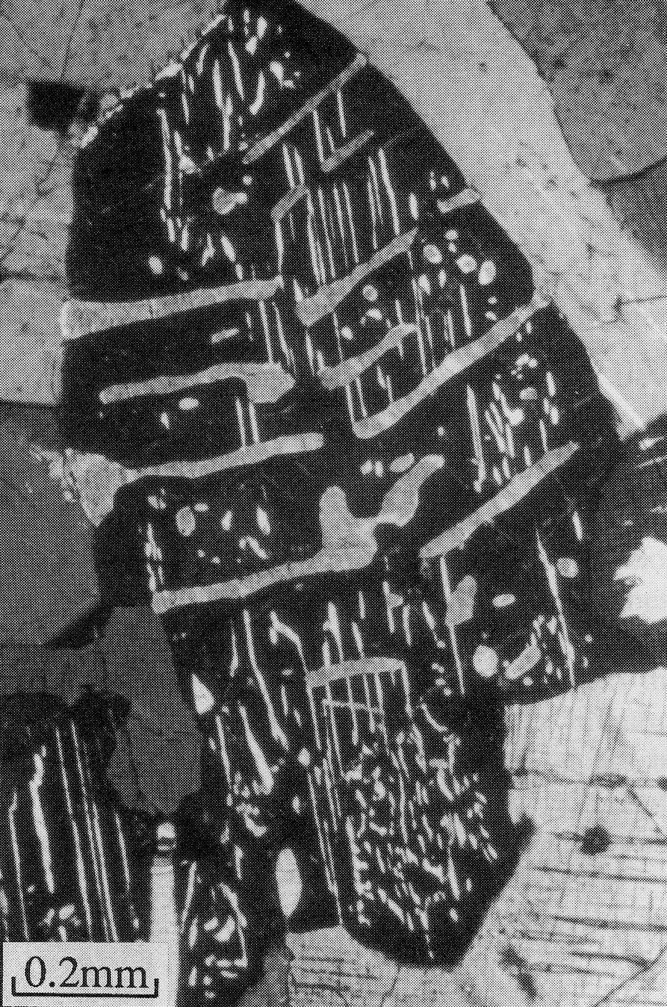

Natural Sciences Tripos Part 1b

GEOLOGICAL SCIENCES B

Igneous Mineralogy

Richard Harrison

-----------
Phase transitions and exsolution phenomena in pyroxenes

Introduction

Pyroxenes are the most important group of ferromagnesian silicates, and occur as stable phases in almost every type of igneous rock. They are also found in many rocks formed under both regional and contact metamorphism and are a major component of mantle peridotite. Their widespread occurrence, varied chemistry, and intricate phase transition behaviour make them excellent minerals for use as geothermometers and geospeedometers (i.e. minerals which are able to record information about the thermal history and cooling rates of rocks). Displacive and reconstructive phase transitions, solid solutions, cation ordering, and exsolution all occur in the pyroxene system. By understanding when, why, and how fast these processes occur, we can begin to understand how the structure and microstructure of pyroxenes at the Earth’s surface relates to their complex thermal history. These two lectures will bring together many of the concepts we have learned so far and apply them to real geological problems.
What you definitely need to know!

By the end of these two lectures you should:

- be familiar with the general structure and chemistry of the pyroxene minerals

- know the differences between the C2/c, P2₁/c, and Pbca pyroxene structures and be able to relate the stability of these different structures to changes in chemistry and temperature

- be familiar with the various types of phase transition and exsolution phenomena in pyroxenes

- understand how the microstructure of exsolved pyroxenes develop and what these microstructures can tell us about the cooling history of the mineral

- be aware of different ways pyroxenes can be used as geothermometers and geospeedometers

- be able to identify pyroxenes in thin section and distinguish between clinopyroxenes and orthopyroxenes
Basic structure of the pyroxenes XYZ₂O₆
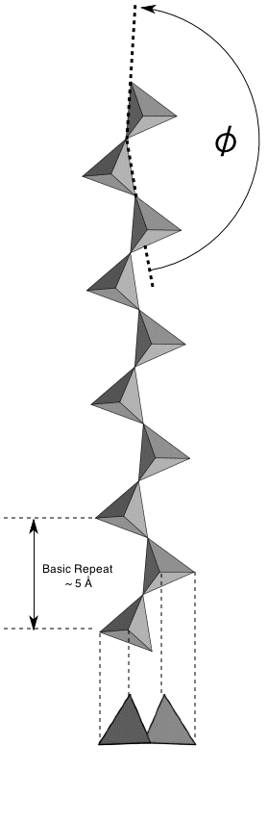
Pyroxenes have a varied chemistry, which can be represented by the general structural formula XYZ₂O₆, where X and Y can be either monovalent (e.g. Na, Li), divalent (e.g. Mg, Fe²⁺, Ca), or trivalent cations (e.g. Al, Fe³⁺). Z is either Si or Al.

Some endmembers we will come across are:

- Enstatite Mg₂Si₂O₆ (or simply MgSiO₃)
- ferrosilite Fe₂Si₂O₆ (or simply FeSiO₃)
- diopside CaMgSi₂O₆
- hedenbergite CaFeSi₂O₆
- Jadeite NaAlSi₂O₆
- Ca-Tschermak CaAl(AlSi)O₆

The basic building blocks of the pyroxene structure are single chains of SiO₄ tetrahedra (Fig. 1). The chains are infinitely long and run parallel to the z-direction. In the ideal structure the chains are straight (φ = 180°), but in reality they are kinked by an angle which varies from structure to structure and with changing temperature and pressure. The chain repeats after every two SiO₄ tetrahedra, yielding an approximately 5 Å repeat distance. This defines the length of the unit cell in the z-axis direction (i.e. the c lattice parameter).

Two silicate chains are joined together via a ribbon of edge-sharing octahedral sites (labelled M1) (Fig. 2). Together, these make a structural unit often referred to as an ‘I-beam’.
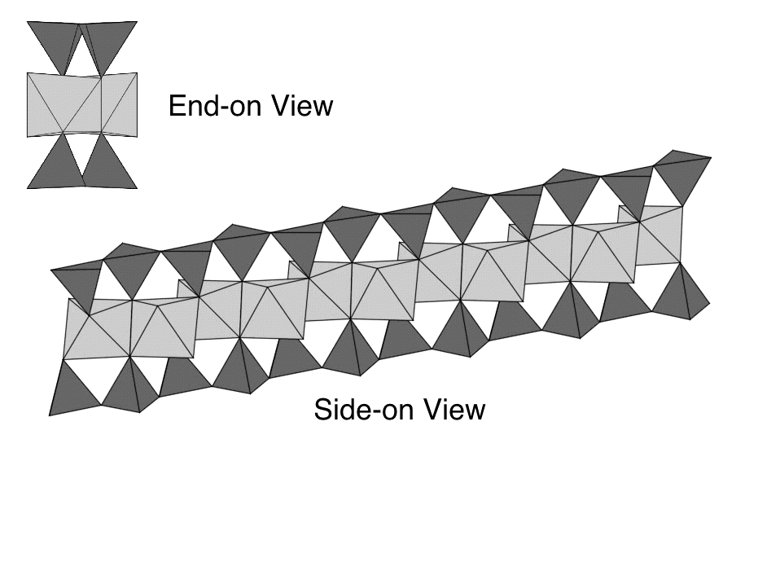
Fig. 1
Fig. 2
Viewed down the z-axis, we can see how these I-beams are joined together to form the rest of the structure (Fig. 3).
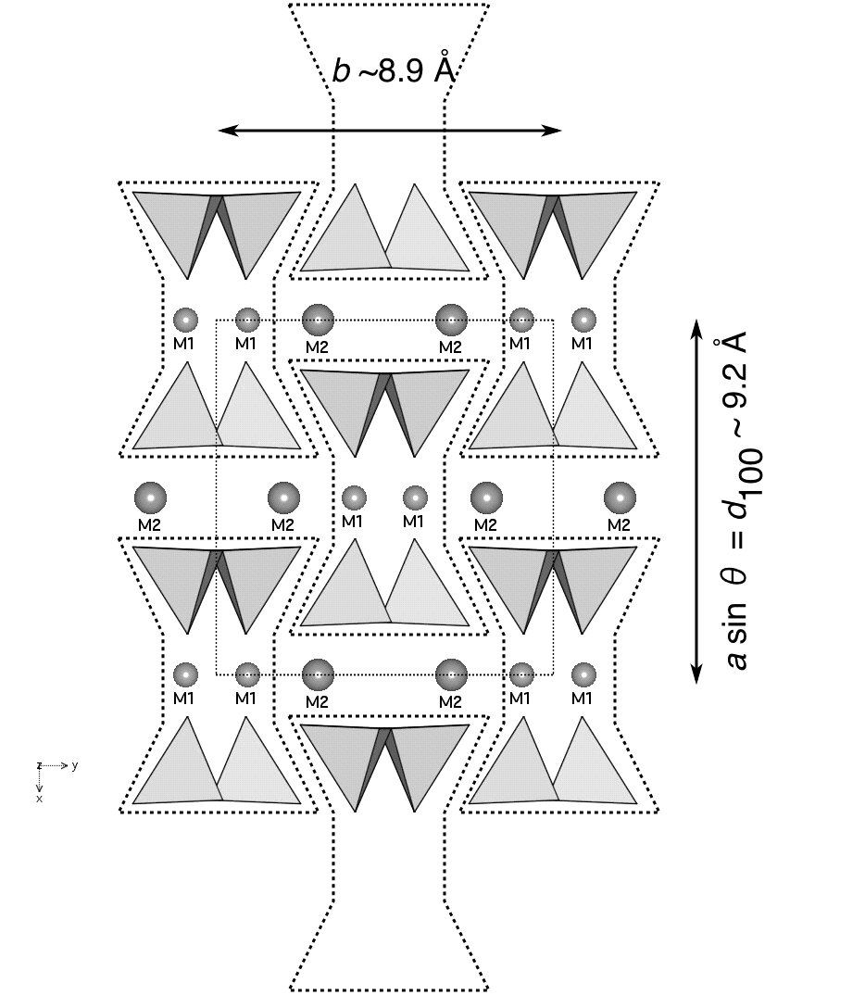
The bases of the I-beams are held together by cation sites labelled M2. The M2 sites are larger and more distorted than the M1 sites. The coordination number can vary from 6 to 8, depending on the specific structure and the size of the cation occupying it.

Clinopyroxene vs. orthopyroxene structures

Fig. 3 shows the structure of diopside (CaMgSi₂O₆), which belongs to the monoclinic crystal system with space group C2/c (crystal class 2/m). Monoclinic pyroxenes are referred to as clinopyroxenes. The other major type of pyroxenes are referred to as orthopyroxenes. These have orthorhombic symmetry with space group Pbca (crystal class mmm). The clino- and orthopyroxene structures differ in the way that the chains are arranged parallel to z (Fig. 4).
Fig. 3
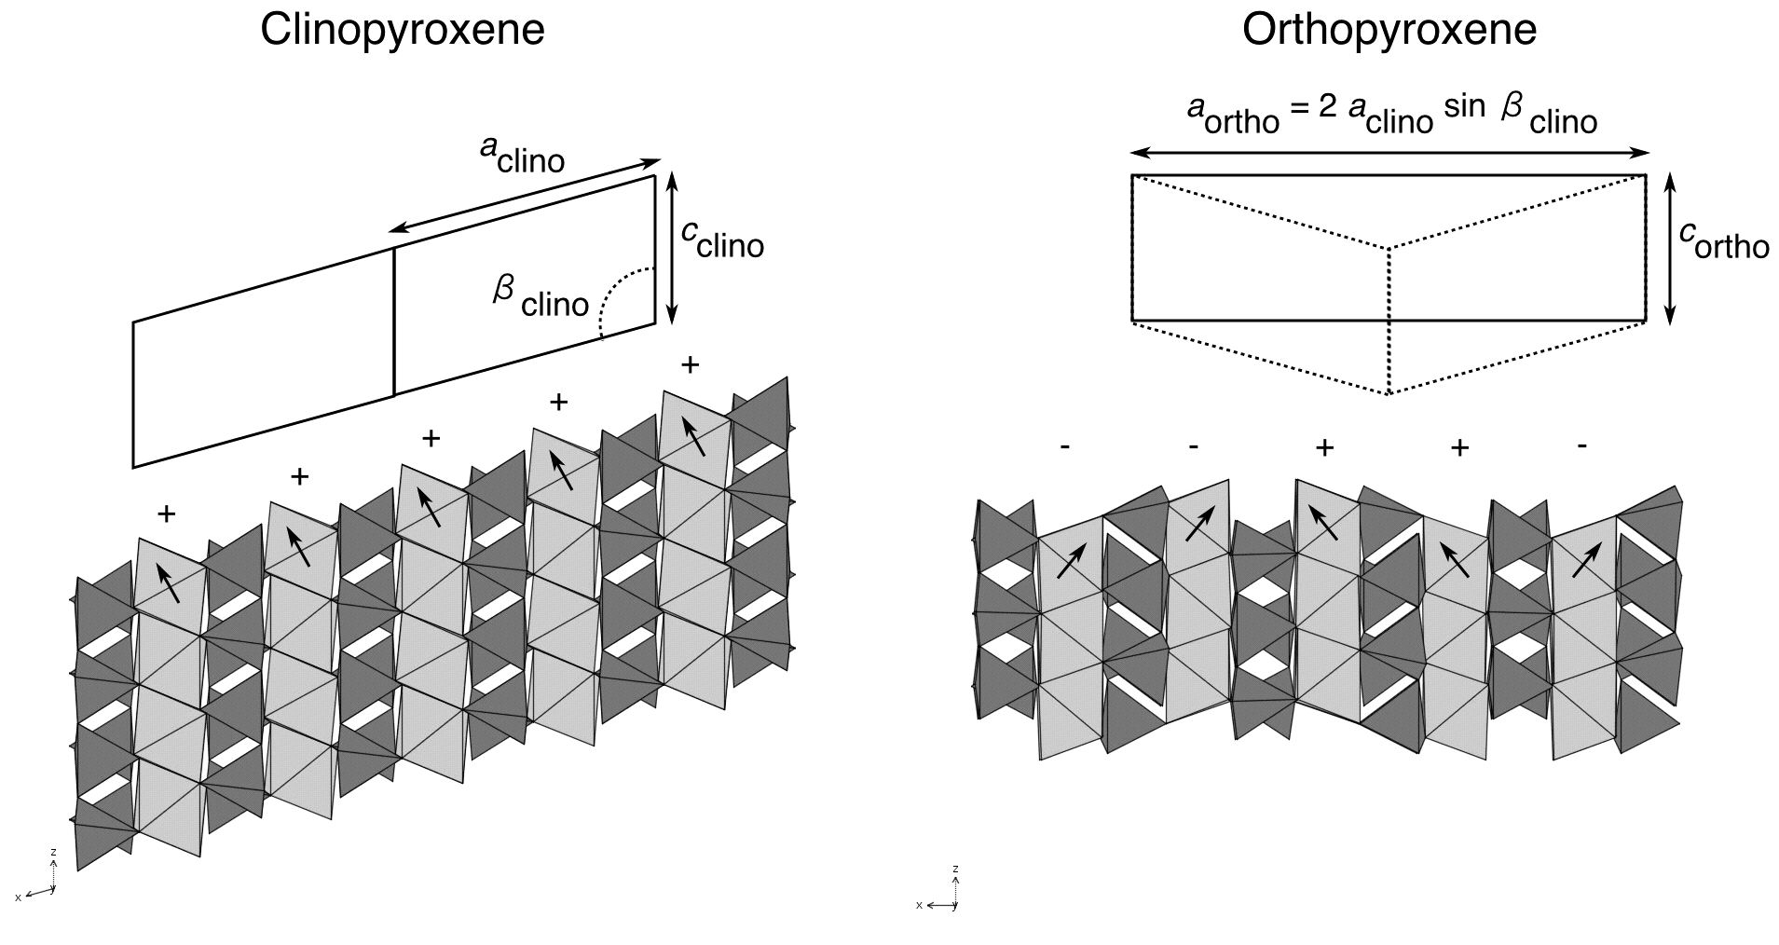
Fig. 4

Note the orientation of the M1 octahedra. There are two possible orientations (labelled + and -), In the clinopyroxene structure all the octahedra are in the + orientation. In the orthopyroxene structure the layers are stacked in the sequence …++--++--++--++--…. The relationship between the monoclinic and orthorhombic unit cells is also shown in Fig. 4. The a lattice parameter of the orthorhombic unit cell is approximately twice the d-spacing of the 100 planes of the monoclinic structure.

A second important type of clinopyroxene has space group P2₁/c. The stacking is identical to the C2/c structure, but the kinking of the tetrahedral chains is different. In the C2/c structure, all chains are kinked in the same sense, and all are related to each other by the space group symmetry. In the P2₁/c structure, chains in adjacent 100 layers are kinked in opposite senses, so that they lose their equivalence and the symmetry is reduced.

Crystal chemistry of the pyroxenes

To understand phase transitions in the pyroxenes we must know how the size of the M1 and M2 cation sites vary from structure to structure.

Table 1 |  | C2/c | Pbca | P2₁/c
M1 | Size and coordination | Small  [6] | Small  [6] | Small  [6]
M1 | Shape | Regular | Regular | Regular
M1 | Cations | Small cations such as  Mg, Fe²⁺, Al | Small cations such as  Mg, Fe²⁺, Al | Small cations such as  Mg, Fe²⁺, Al
M2 | Size | Large  [8] | Small  [6]-[7] | Small  [7]
M2 | Shape | Irregular | Irregular | Irregular
M2 | Cations | Large cations such as  Na, Ca | Only small cations such as Mg and Fe²⁺  Very little Ca! | Small amount of Ca is tolerated. Mainly Mg and Fe²⁺

Solid solutions and the pyroxene quadrilateral

The most important natural pyroxene minerals are formed from solid solutions involving Mg, Fe²⁺, and Ca. The range of compositions can be represented by the pyroxene quadrilateral (Fig. 5). There are three important solid solutions contained within the quadrilateral: the orthopyroxene solid solution (often referred to as hypersthene), the pigeonite solid solution, and the augite solid solution.
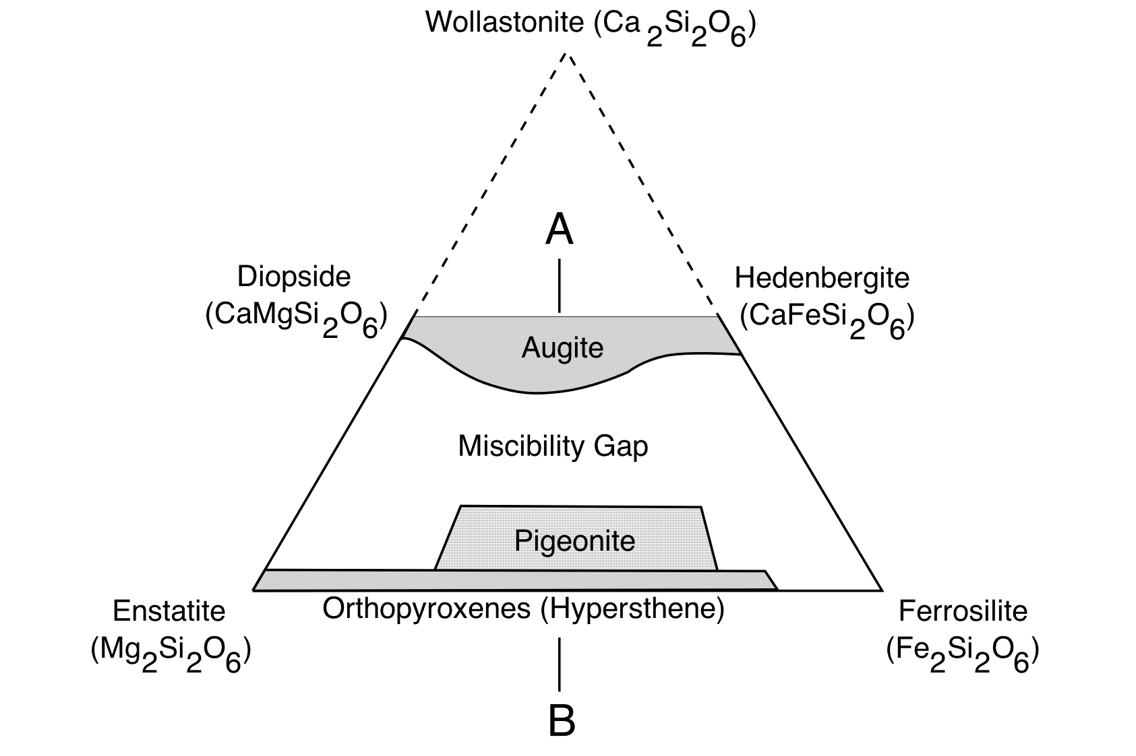
Fig. 5
Orthopyroxene solid solution

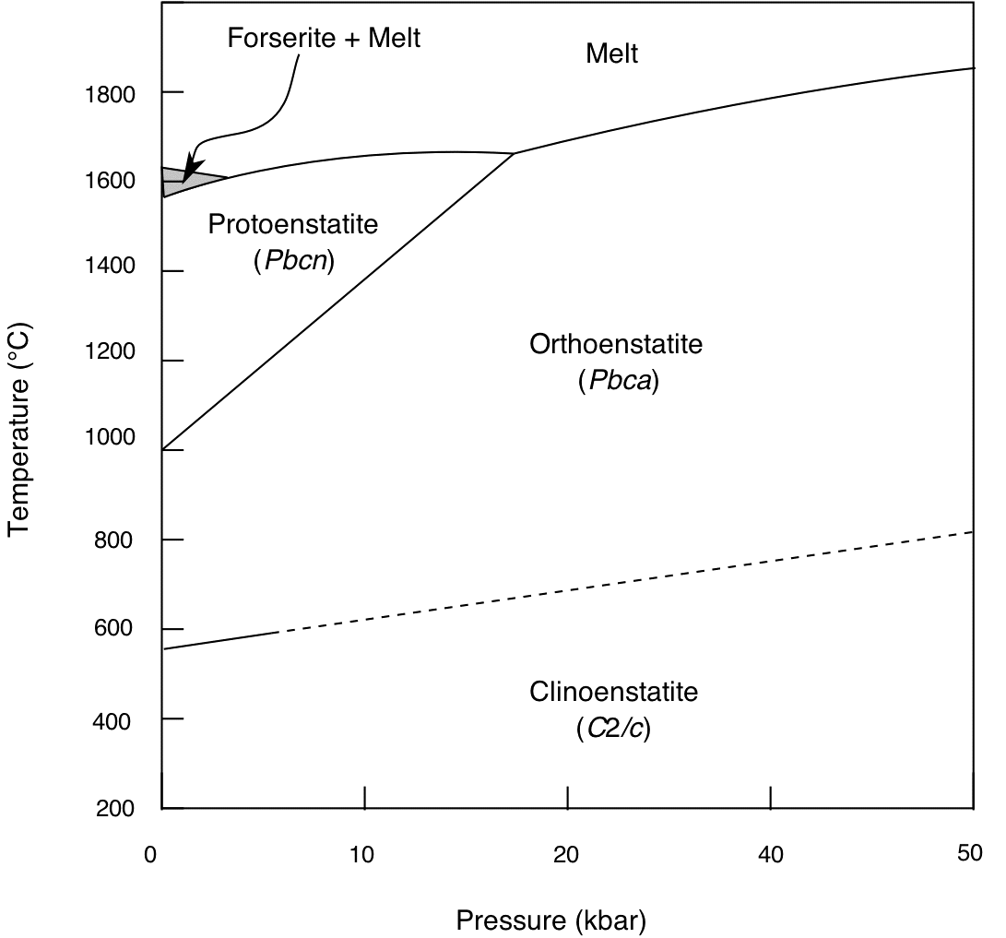
The orthopyroxene solid solution is formed between the endmembers enstatite (Mg₂Si₂O₆) and ferrosilite (Fe₂Si₂O₆). Enstatite exists in three different polymorphs: protoenstatite (Pbcn), orthoenstatite (Pbca), and clinoenstatite (C2/c). Protoenstatite is stable at temperatures above 1000 °C, but is never found in nature (Fig. 6). It has an orthorhombic structure based on …+-+-+-+-… stacking of the octahedral layers. The a lattice parameter of protenstatite is, therefore, half the size of orthoenstatite, which has the usual …++--++--++--++--… stacking (Fig. 4). Below 1000 °C protoenstatite transforms to orthoenstatite and then to clinoenstatite below 600 °C. The kinetics of the orthoenstatite to clinoenstatite transition are slow, and the orthorhombic structure may be easily quenched to room temperature. Orthoenstatite is the most common form in nature.
Fig. 6

Ferrosilite is not stable at low pressure, and breaks down to a mixture of fayalite and quartz. The orthoferrosilite structure (Pbca) is stable at pressures above 10 kbar and temperatures above 400-600 °C. At lower temperatures it transforms to the clinoferrosilite form (P2₁/c), but again the kinetics of this transformation are slow.

The intermediate members of the orthopyroxene solid solution are referred to as hypersthene. The solid solution involves mixing of Mg and Fe²⁺ on the M1 and M2 sites (due to the small size of M2, this structure will not tolerate large amounts of Ca). Mixing is not ideal, since there is a marked preference for the larger Fe²⁺ cation to occupy M2 sites. This leads to a special kind of cation ordering phenomenon, whereby Fe²⁺ cations are ordered onto M2 at low temperatures, but become increasingly disordered over M1 and M2 at high temperatures (the disordered distribution has a higher entropy, and is therefore favoured at high temperature). We can measure the cation distribution experimentally and get an estimate of the equilibration temperature of the rock.

Pigeonite solid solution

Hypersthene transforms to the clinopyroxene (C2/c) structure at high temperatures. This structure has an expanded M2 site, and can accept larger amounts of Ca substituting for (Mg, Fe²⁺). This region of Ca-poor monoclinic solid solution is referred to as pigeonite.

Augite

The endmembers diopside (CaMgSi₂O₆) and hedenbergite (CaFeSi₂O₆) are both clinopyroxenes (C2/c). Ca occupies M2 and there is complete solid solution between Mg and Fe²⁺ on M1. The term augite is used to describe the Ca-rich clinopyroxene solid solution.

The pure Ca endmember Wollastonite (Ca₂Si₂O₆) is not a pyroxene mineral. Although it has a structure based on chains of SiO₄ tetrahedra, the chains have a three-tetrahedra repeat, rather than a two-tetrahedra repeat (see Fig. 1). Wollastanite belongs to a class of structures called the pyroxenoids.

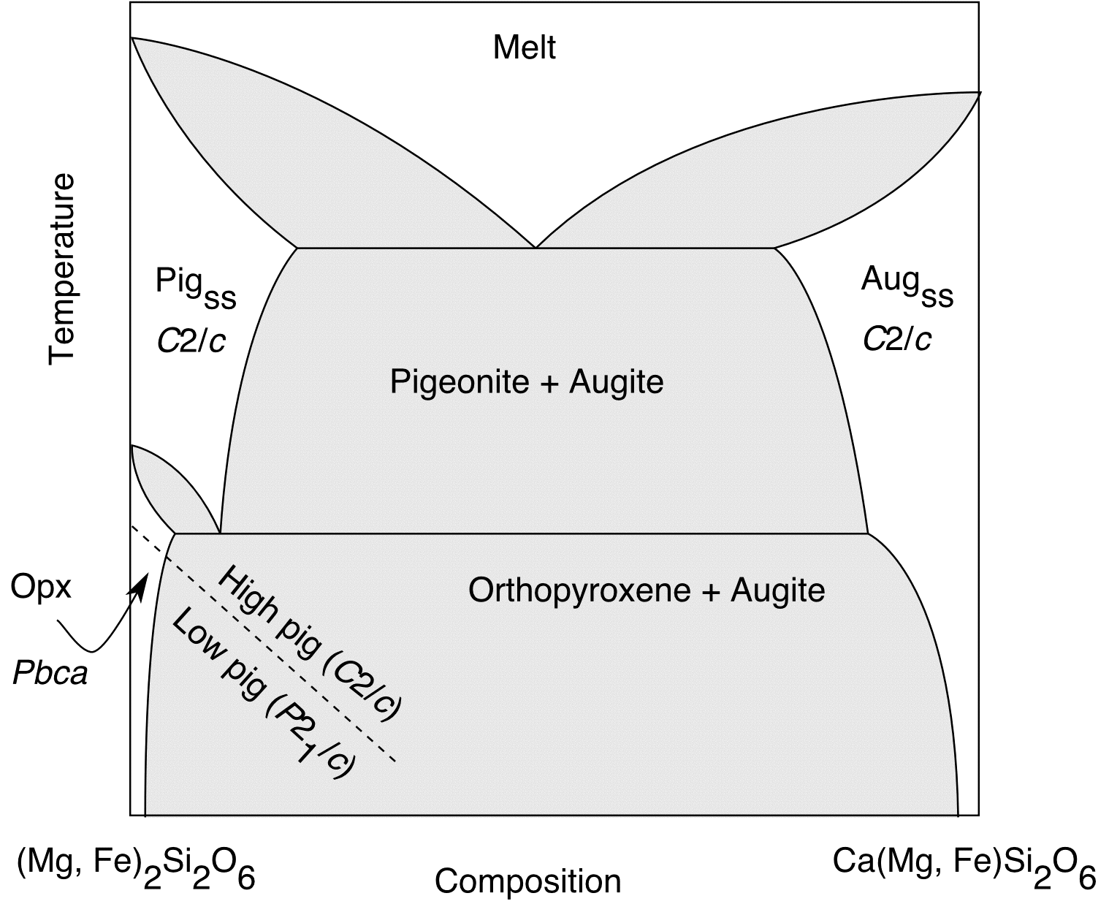
Fig. 7
Phase transitions in the pyroxenes

Fig. 7 shows a section through the pyroxene phase diagram taken along the join A-B in Fig. 5. We can consider this as a binary phase diagram between the ‘endmembers’ pigeonite and augite. The subsolidus phase relations are dominated by the following features:

Miscibility gap and high-T eutectic point

Both pigeonite and augite have the monoclinic structure and can accept Ca into their large M2 site. However, due to the large difference in the cation radii of (Mg, Fe²⁺) and Ca, there is a large enthalpy of mixing in the solid solution and a miscibility gap at intermediate compositions (see solid solutions handout). The high temperature part of the phase diagram consists of two melting loops and a eutectic point. This is a typical crystallisation phase diagram for systems where there is limited miscibility between the two endmembers. The origin of this phase diagram topology is described in detail in Fig. 15 of the solid solutions handout.

Reconstructive phase transition and low-T eutectoid point

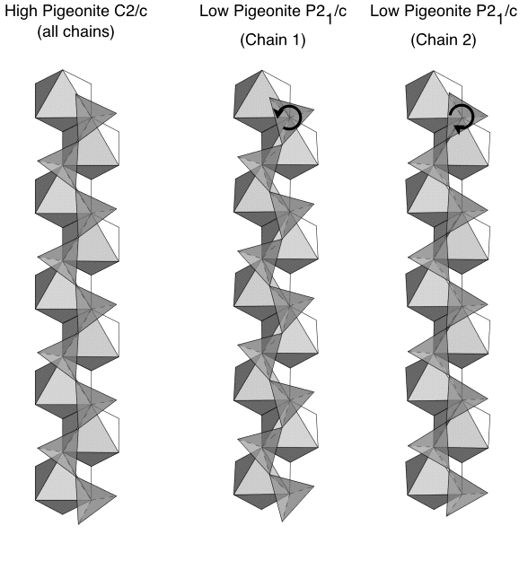
In Ca-poor members of the pigeonite solid solution, the Mg and Fe²⁺ cations are too small for the large M2 site of the monoclinic structure. This size mismatch is tolerated at high temperatures, because the cations are able to vibrate and prevent the structure from collapsing. At lower temperatures, however, it is preferable for the structure to transform to the orthopyroxene structure, which has a much smaller M2 site. In response to the reconstructive phase transition, the phase diagram develops a loop of immiscibility between Ca-poor orthopyroxene and the Ca-rich pigeonite, which intersects the pre-existing miscibility gap at a eutectoid point. The origin of this phase diagram topology is described in Fig. 17 of the solid solutions handout.

Displacive phase transition

If pigeonite is cooled rapidly, then the reconstructive phase transition to orthopyroxene does not take place. Now the structure must find a different way of accommodating the small Mg and Fe²⁺ cations in the large M2 site. In high pigeonite (C2/c) the tetrahedral chains are almost straight (φ = 174°) and the cation sites are large (Fig. 8). The best way to reduce the size of the M1 and M2 sites is to increase the kinking of the chains. In this case, chains in adjacent 100 layers rotate in opposite senses, leading to a displacive phase transition to the low pigeonite structure (P2₁/c). The chains in adjacent layers are kinked by angles φ = 149° and φ = 170°, respectively, reducing the M2 site from [8] coordination to [7]. The collapse of the structure around the small Mg and Fe²⁺ cations can be prevented by the presence of larger Ca cations. Hence the phase transition temperature decreases with increasing Ca content in the solid solution (see dashed line in Fig. 7).
Fig. 8
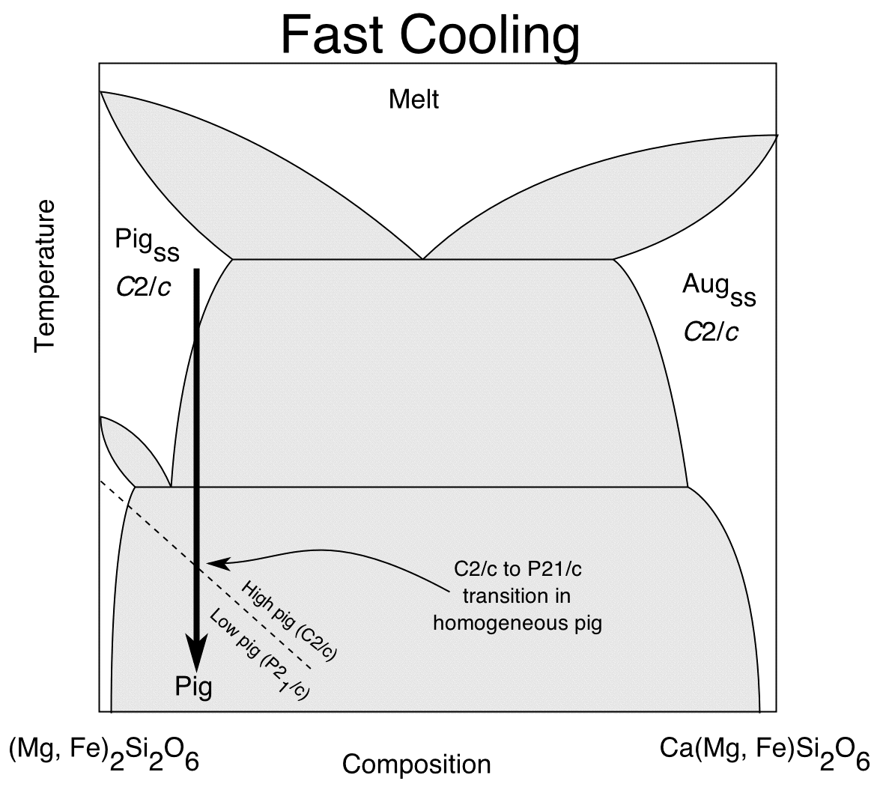
Exsolution phenomena in pyroxenes

The sequence of events which occur during crystallisation and cooling of a pyroxene depends to a large extent on the cooling rate. The history of which events occurred, and to some extent at what temperatures they occurred, is recorded in the microstructure of the mineral. More information is recorded in the actual compositions of the exsolved phases. With some knowledge of the equilibrium phase diagram and the kinetics of the processes involved, it is possible to use pyroxenes as both a geothermometer and geospeedometer.
Fig. 9

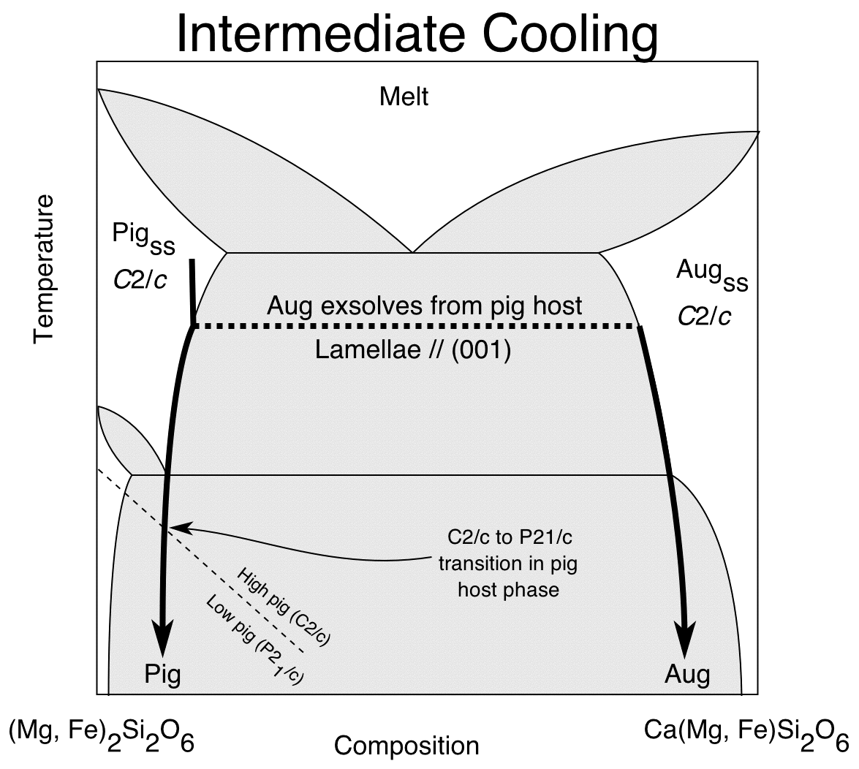
Very rapid cooling of pigeonite solid solutions

In rapidly-cooled (e.g volcanic) rocks, there is no time for either cation diffusion to take place or for the reconstructive phase transition from clinopyroxene to orthopyroxene (Fig. 9). A rapidly-cooled crystal of pigeonite would remain as a homogeneous phase with C2/c symmetry until the temperature of the high-low pigeonite phase transition is reached. Since this is a displacive phase transition (no long-range diffusion or bond-breaking is required), the structure spontaneously distorts to the P2₁/c low pigeonite structure. Since both C2/c and P2₁/c belong to the same point group (2/m) there will be no transformation twins developed during the transition. Antiphase domains may develop due to the loss of translational symmetry (from a C-lattice to a P-lattice) but these will only be visible in a transmission electron microscope.
Fig. 10

Intermediate cooling of pigeonite solid solutions

With intermediate cooling there may be enough time for diffusion of Mg, Fe, and Ca through the structure to take place, in which case very fine-scale exsolution lamellae of augite will begin to form in the pigeonite host crystal when entering the miscibility gap (Fig. 10). The compositions of host pigeonite and augite lamellae evolve with decreasing temperature (kinetics permitting), until the eutectoid temperature is reached. Here the pigeonite host would like to transform to hypersthene, but unless the cooling is very slow, this will not happen. Instead, the pigeonite continues to cool down until it reaches the temperature of the high-low transition, below which it spontaneously distorts to the P2₁/c structure.
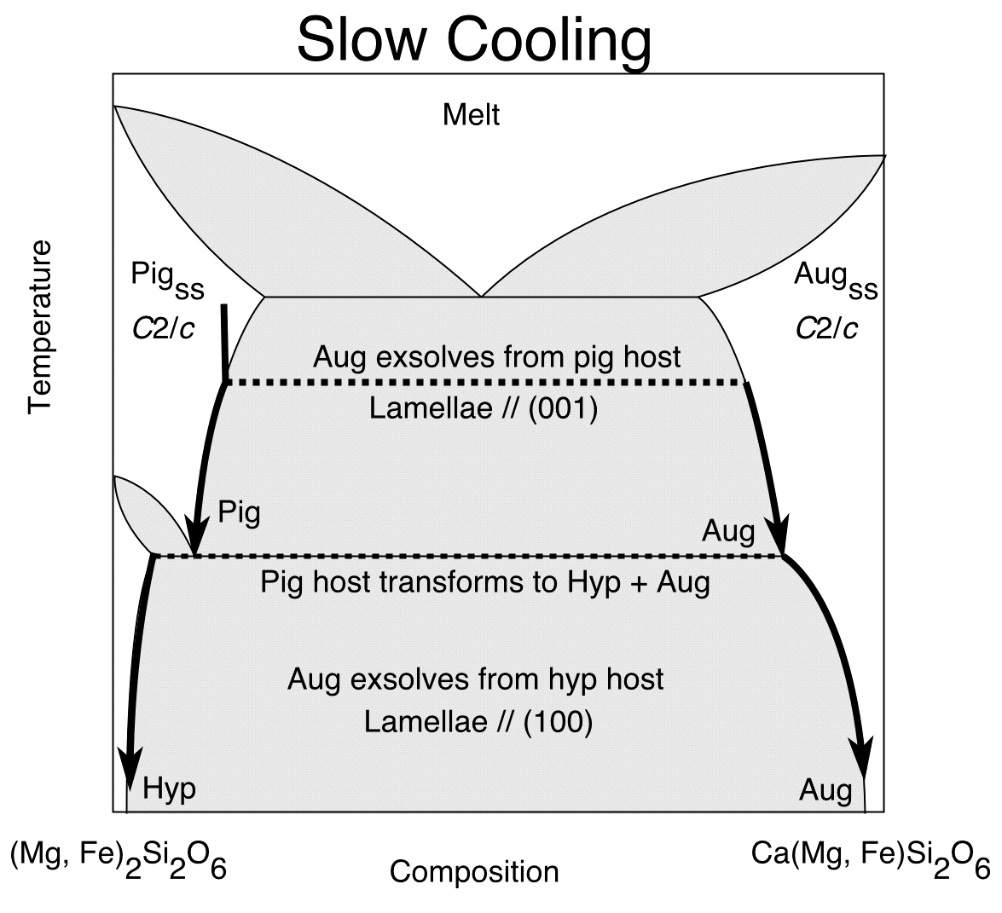
Very slow cooling of pigeonite solid solutions

When cooling is very slow the system will be able to remain in equilibrium during cooling, so that both exsolution and the reconstructive phase transition from pigeonite to hypersthene are possible. As for intermediate cooling, we initially see exsolution lamellae of augite forming within a host of pigeonite. At the eutectoid temperature, the host ‘inverts’ to the orthorhombic hypersthene. This phase contains much less Ca than the monoclinic host did, and the excess Ca is kicked out as a second generation of augite lamellae (Fig. 11).
Fig. 11

Microstructures of exsolved pyroxenes

Orientation of exsolution lamellae

When exsolution occurs, the exsolving phase usually forms as thin lamellae with a very specific crystallographic orientation (Fig. 12). This orientation is chosen to minimise the mismatch in the lattice parameters between the two phases. This has the effect of minimising the strain energy associated with keeping the two lattices in congruence with each other at the interface (the so-called coherency strain).
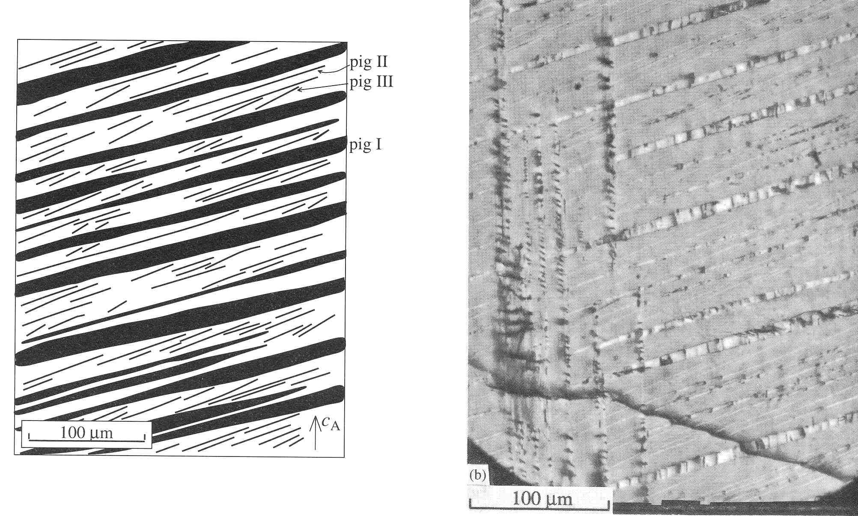
Fig. 12
In the case of augite lamellae exsolving from pigeonite (or pigeonite lamellae exsolving from augite) the lamellae prefer to grow in an orientation close to the (001) planes of the host. Such lamellae are referred to as “001” lamellae. The quotation marks indicate that the orientation is close to but not precisely parallel to (001). The precise orientation is determined by the lattice parameters of the host and lamellae phases, and is a function of temperature and bulk composition (Fig. 13). The orientations can be derived using a simple geometrical argument (we will not go into the details here. Those interested should consult Putnis - Introduction to Mineral Sciences). Large changes in lamellar orientation occur on either side of the high-low pigeonite phase transition, since the transition causes a significant change in lattice parameters of the pigeonite phase.

!!!! We can use these observations to constrain the temperature at which a particular generation of exsolution lamellae formed !!!!

For example, note the change in orientation of the 1st generation (thick), 2nd-generation (intermediate) and 3rd generation (thin) lamellae in Fig. 12.

The second best orientation for pigeonite lamellae in augite (and augite lamellae in pigeonite) is close to (100). These “100” lamellae have around twice the coherency energy of “001” lamellae, but may appear when the solid solution becomes highly supersaturated.

On the other hand, when augite exsolves from hypersthene (or vice versa), the preferred orientation is always parallel to (100). This helps us to further constrain the temperature at which exsolution took place.

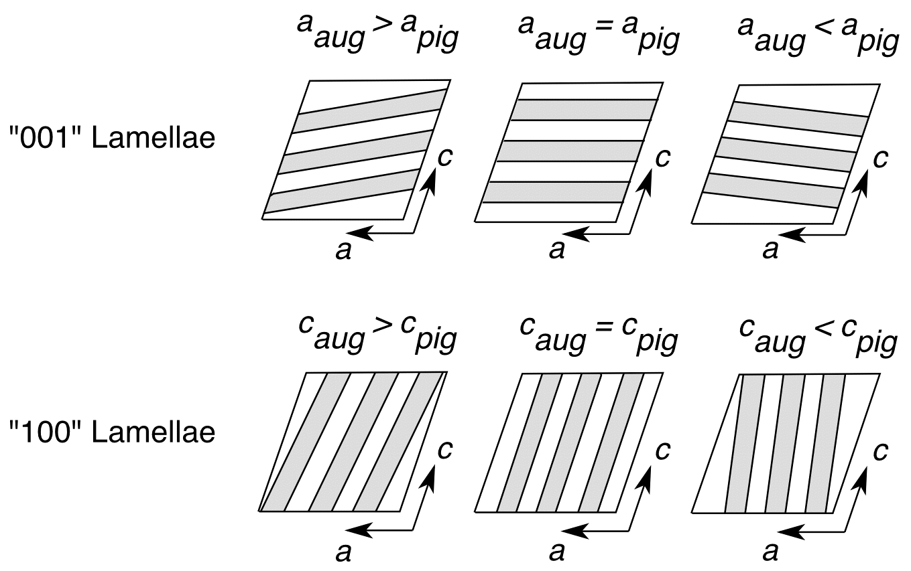

Fig. 13
Spacing of lamellae

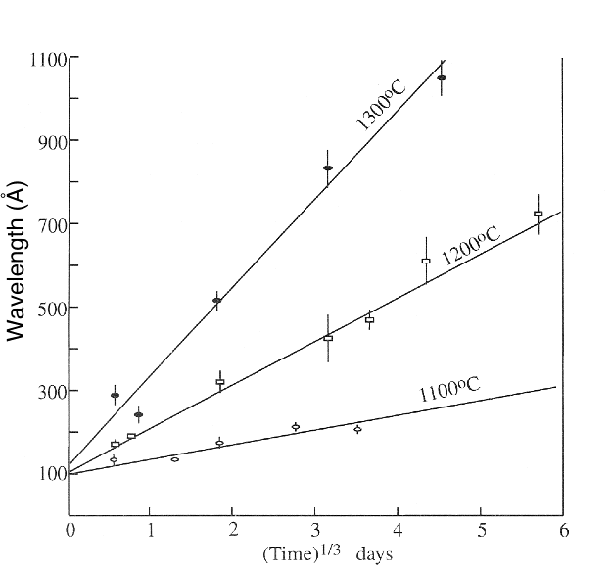
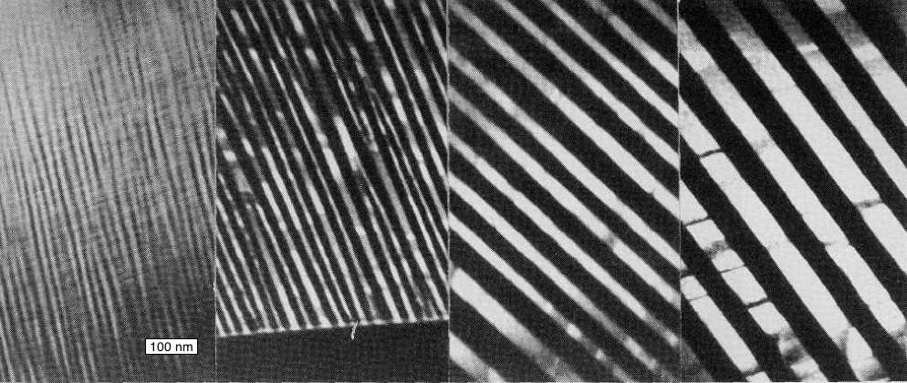
The thickness and the spacing of lamellae can also be used as an indicator of the temperature of their formation and the general cooling rate of the mineral. Fig. 14 shows how the width and spacing of a pigeonite-augite intergrowth changes with increasing annealing time at 1000 °C (times correspond to 39, 359, 1606, and 3886 hours). The graph demonstrates that the spacing of the lamellae is proportional to (annealing time)^{1/3}.

Fig. 14
Inverted pigeonite

Very slowly cooled pigeonite crystals show a characteristic microstructure referred to as “inverted pigeonite”. An example is shown in Fig. 15.
Fig. 15
This crystal began life as a homogeneous twinned crystal of pigeonite. The twin is a growth twin. One twin component corresponds to the clinopyroxene structure with stacking sequence …++++++…. The other component has the same structure but with stacking sequence …-------… (Fig. 16). The (100) planes of the two components are parallel, but the (001) planes make an angle of 360 - 2β° to each other.

On cooling, the pigeonite begins to exsolve lamellae of augite parallel to (001) of the host. The different orientation of the (001) planes in the two twin components gives the crystal the characteristic “herringbone” appearance.

On cooling through the eutectoid temperature, the pigeonite host “inverts” to the orthorhombic structure. The external shape of the crystal remains the same, so although the symmetry of the host is now orthorhombic, its shape still reflects the monoclinic symmetry of the original pigeonite. Such a crystal is known as a pseudomorph.

From now on, exsolution of augite lamellae occurs parallel to (100) of the orthorhombic host. This later stage exsolution of “100” lamellae can clearly be seen in Fig. 15, cutting through the previous generation of “001” lamellae.
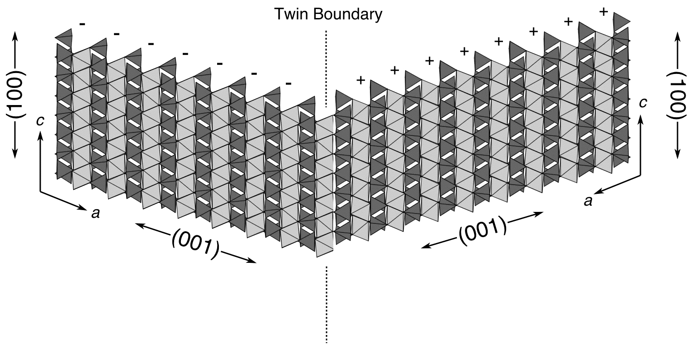
Fig. 16
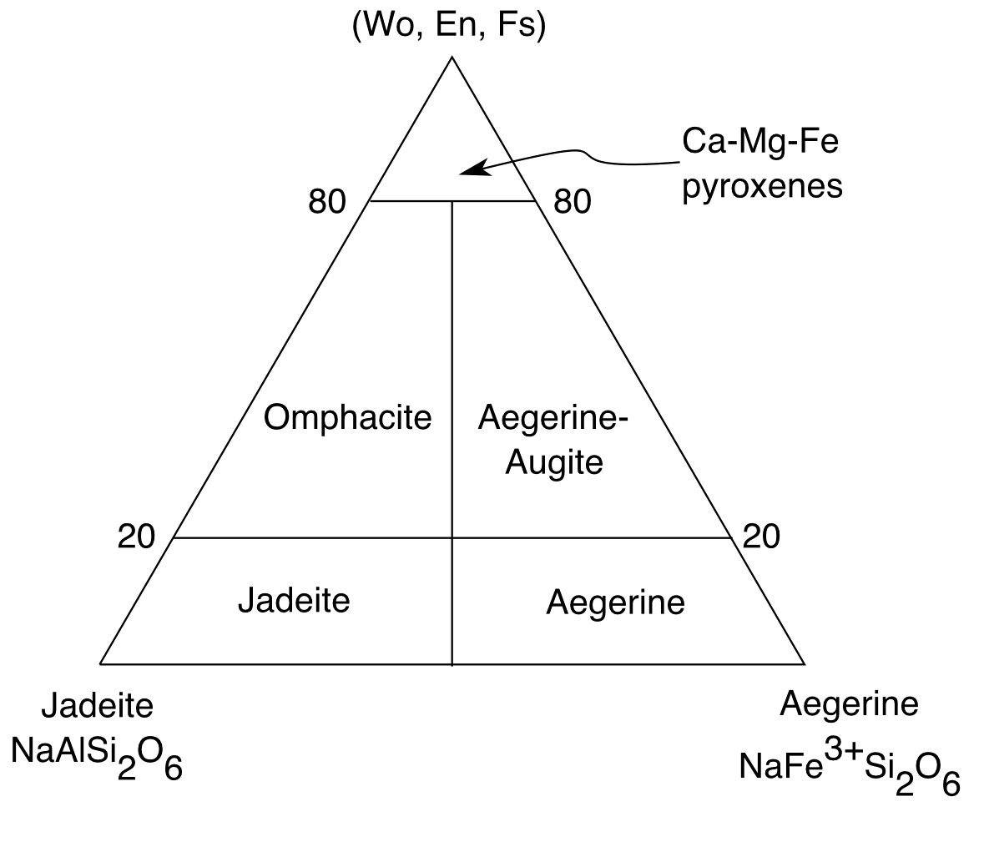
Cation ordering in the Na-bearing pyroxenes

Another major group of pyroxenes are those containing Na, Al, and Fe³⁺ (Fig. 17). The endmember jadeite (NaAlSi₂O₆) is stable at high pressures and forms from the reactions:

nepheline (NaAlSiO₄) + albite (NaAlSi₃O₈) -> 2 jadeite (NaAlSi₂O₆)

and
Fig. 17
albite (NaAlSi₃O₈) -> jadeite (NaAlSi₂O₆) + quartz (SiO₂)

The structure is monoclinic (C2/c) with Al on M1 and the larger Na cations on M2.
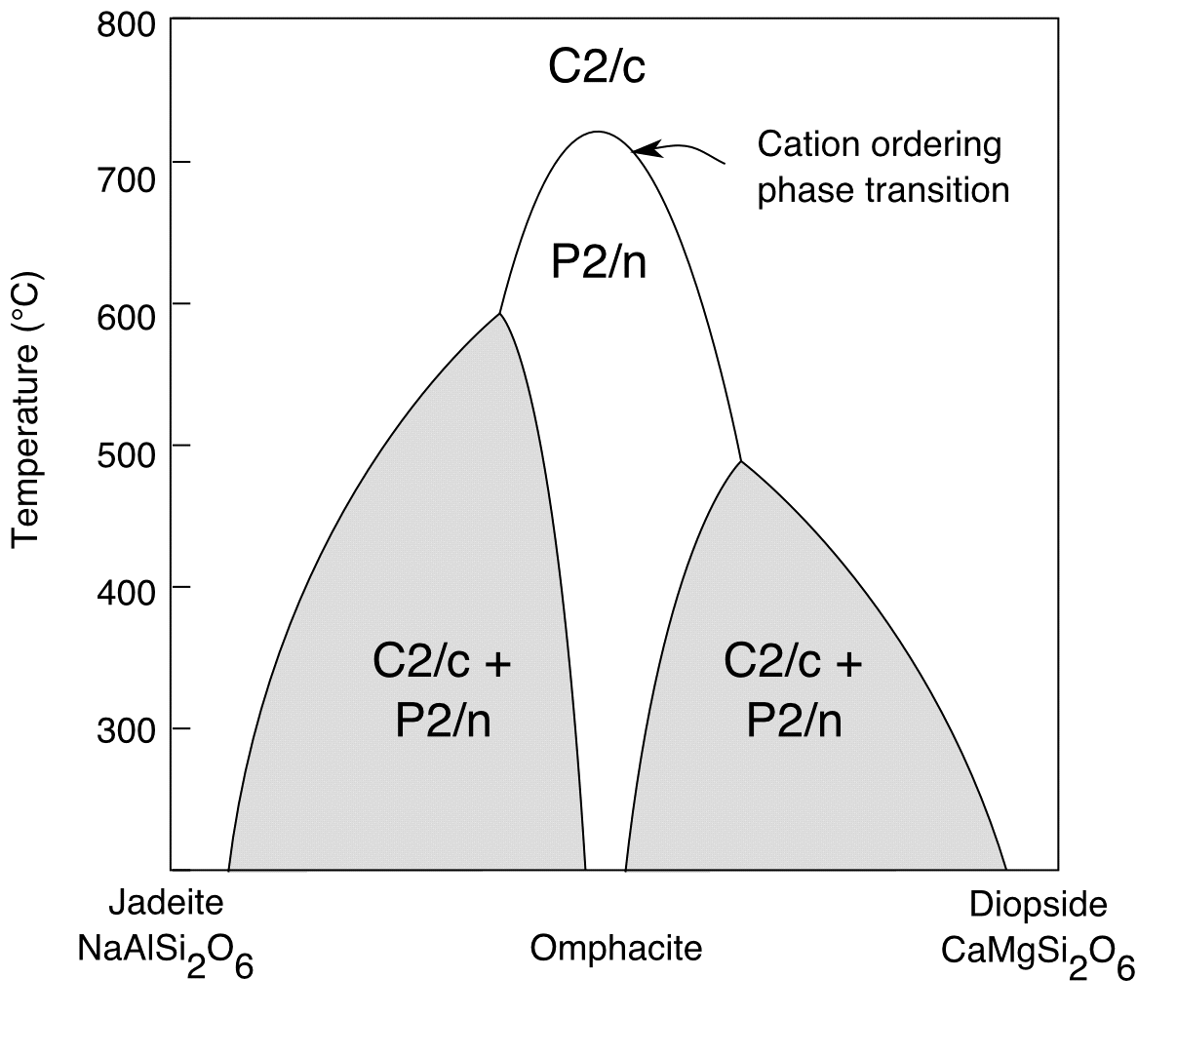
The binary solid solution between jadeite and diopside is formed by substituting Al for Mg on M1 sites and Na for Ca on M2 sites (a coupled substitution). When two cations of different valence mix, the nearest-neighbour Coulombic contribution to the enthalpy of mixing is negative. A negative enthalpy of mixing implies that ‘unlike’ nearest-neighbours (i.e. A-B) are favoured over ‘like’ nearest-neighbours (i.e. A-A and B-B) (see solid solutions handout). The system will try to maximise the number of unlike nearest-neighbours by ordering the cations. This results in a cation ordering phase transition near the centre of the solid solution.
Fig. 18

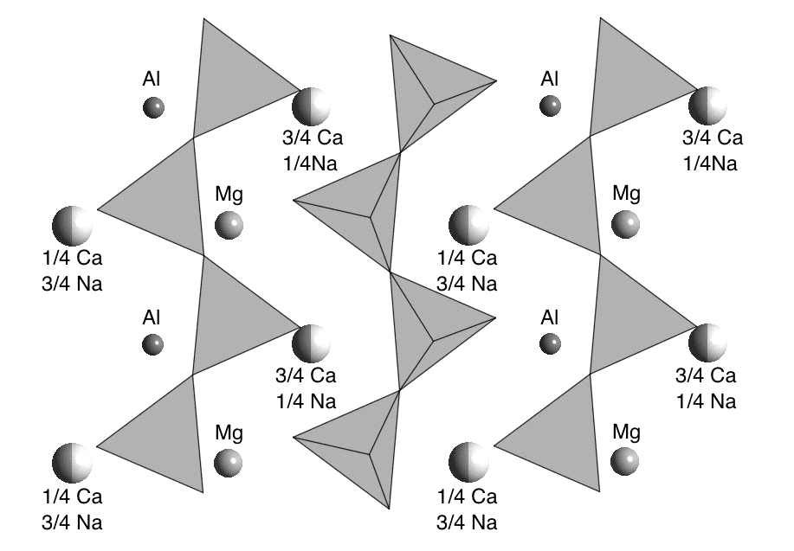
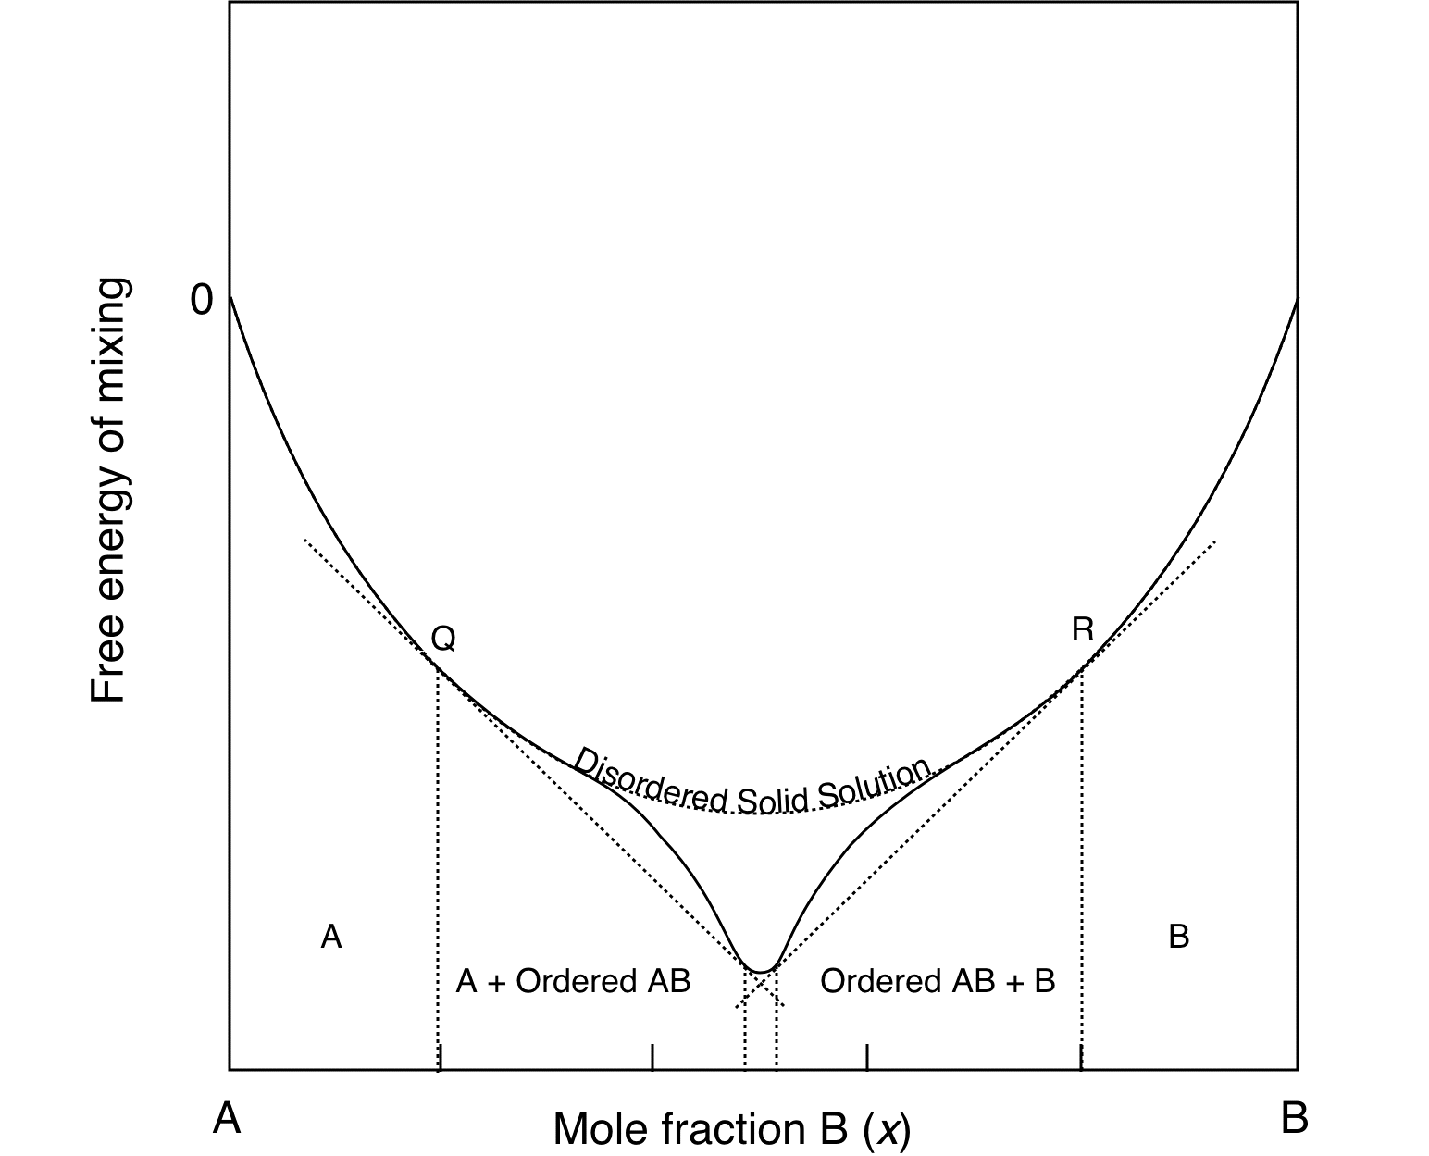
The binary phase diagram for the jadeite-diopside solid solution is shown in Fig. 18. There is complete solid solution at high temperatures. The central region of the solid solution is referred to as omphacite with ideal composition (Na_{0.5}Ca_{0.5})(Al_{0.5}Mg_{0.5})Si₂O₆. Above 700 °C omphacite has C2/c symmetry. In this phase Al and Mg are randomly mixed on M1 and Na and Ca are randomly mixed on M2. Below 700 °C Al and Mg order onto alternating M1 sites along the ribbons parallel to z. Na and Ca become partially ordered onto alternating M2 sites, such that one M2 site is occupied on average by 3/4 Ca and 1/4 Na, while the adjacent site is occupied on average by 1/4 Ca and 3/4 Na (Fig. 19).
Fig. 19
Fig. 20

The decrease in free energy associated with the cation ordering phase transition in the centre of the solid solution is large enough to generate two miscibilty gaps on either side of the ordered intermediate phase (Fig. 20).

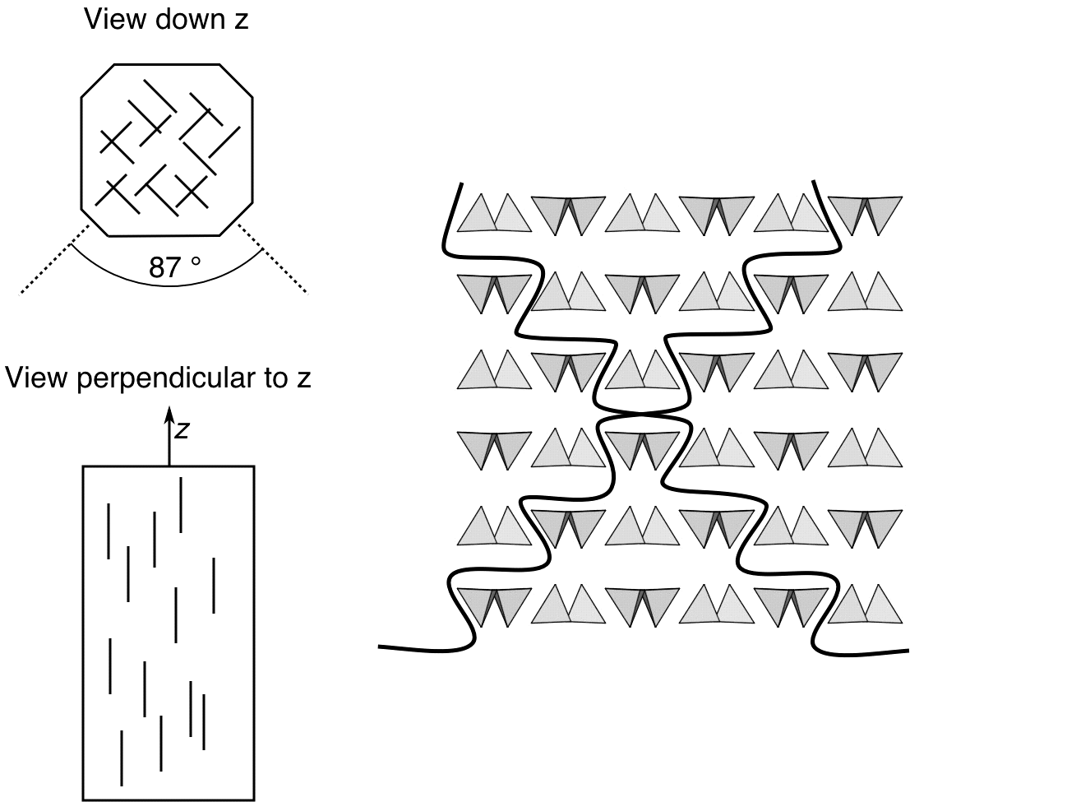
Identification of pyroxenes in thin section

The most characteristic feature of pyroxene minerals is the presence of two well developed cleavage traces at approximately 90° to each other, running parallel to {110} in the clinopyroxenes and parallel to {210} in the orthopyroxenes (remember the orthopyroxenes have approximately double the lattice parameter of the clinopyroxenes in the x direction!) (Fig. 21).
Fig. 21
Orthopyroxenes

- The orthopyroxenes have orthorhombic symmetry and consequently parallel extinction with respect to the {210} cleavage traces.

- Orthopyroxenes have lower birefringence than pigeonite and augite, yielding maximum interference colours from low first order to very low second order.

- Colourless to only faintly coloured in plane polarized light. More Fe-rich orthopyroxenes are more strongly coloured in pale browns and greens. Fe-rich orthopyroxenes are also pleochroic (pink to green), with pleochroism becoming apparent at approximately 30% replacement of Mg by Fe.

- Orthopyroxenes can be either biaxial positive or negative. 2V angles vary systematically with composition. Compositions may be determined if both 2V and optic sign have been determined (see description in olivine handout). The composition versus 2V diagrams are double valued (i.e. both high- and low-Mg pyroxenes have similar values of optic sign and 2V). However, Mg-rich orthopyroxenes can be easily distinguished from Fe-rich orthopyroxenes based on the more intense colours of the Fe-rich varieties.

Pigeonite

- Pigeonites are monoclinic and have inclined extinction with respect to the {110} cleavage traces (extinction angles 30-50°).

- Pigeonites have higher refractive indices and birefringence (0.023-0.029) than orthopyroxenes. The birefringence yields maximum interference colours in the middle of the second order.

- Pigeonites are generally colourless.

- Biaxial positive with relatively small 2V_{γ} (< 25°).

- Pigeonites can be distinguished from augites by their lower 2V angles (2V for most augites is around 50 degrees).

Augite

- Augite is monoclinic and has inclined extinction with respect to the {110} cleavage traces (extinction angles 30-50°).

- Augite has higher birefringence (0.018- 0.033) than orthopyroxenes, giving maximum interference colours in the second order. Birefringence increases with increasing Fe-content.

- Colour generally pale brown to pale green in all but the most Mg-rich rocks (i.e., peridotites). Intensity of colour increases with increasing Fe-content. Titanaugite (small amount of Ti⁴⁺ substitution on M1) has a characteristic purplish-brown pleochroism.

- Biaxial positive with 2V_{γ} = °.

- Augites can be distinguished from orthopyroxenes based on their higher birefringences and inclined extinction. Augites can be distinguished from pigeonites based on their higher 2V angles.

The following pictures are available in colour in the on-line version of the handout.

Twinned clinopyroxene crystal with “100” orthopyroxene lamellae
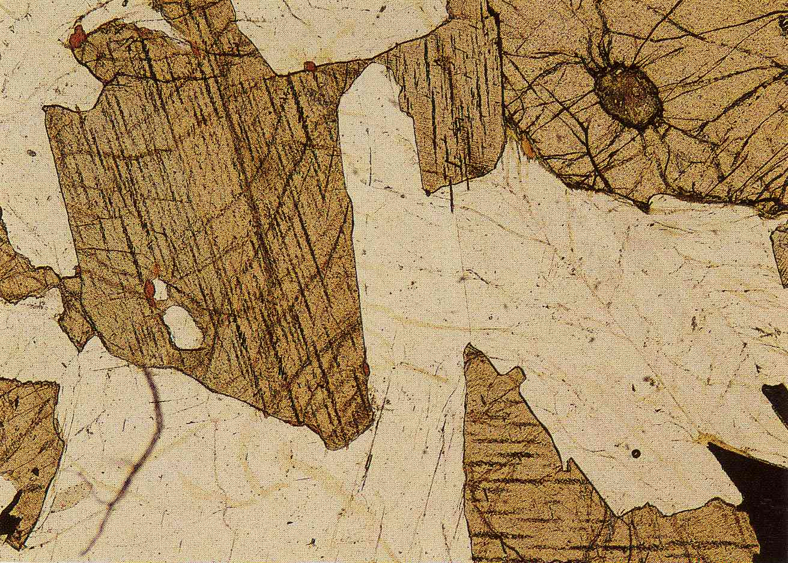
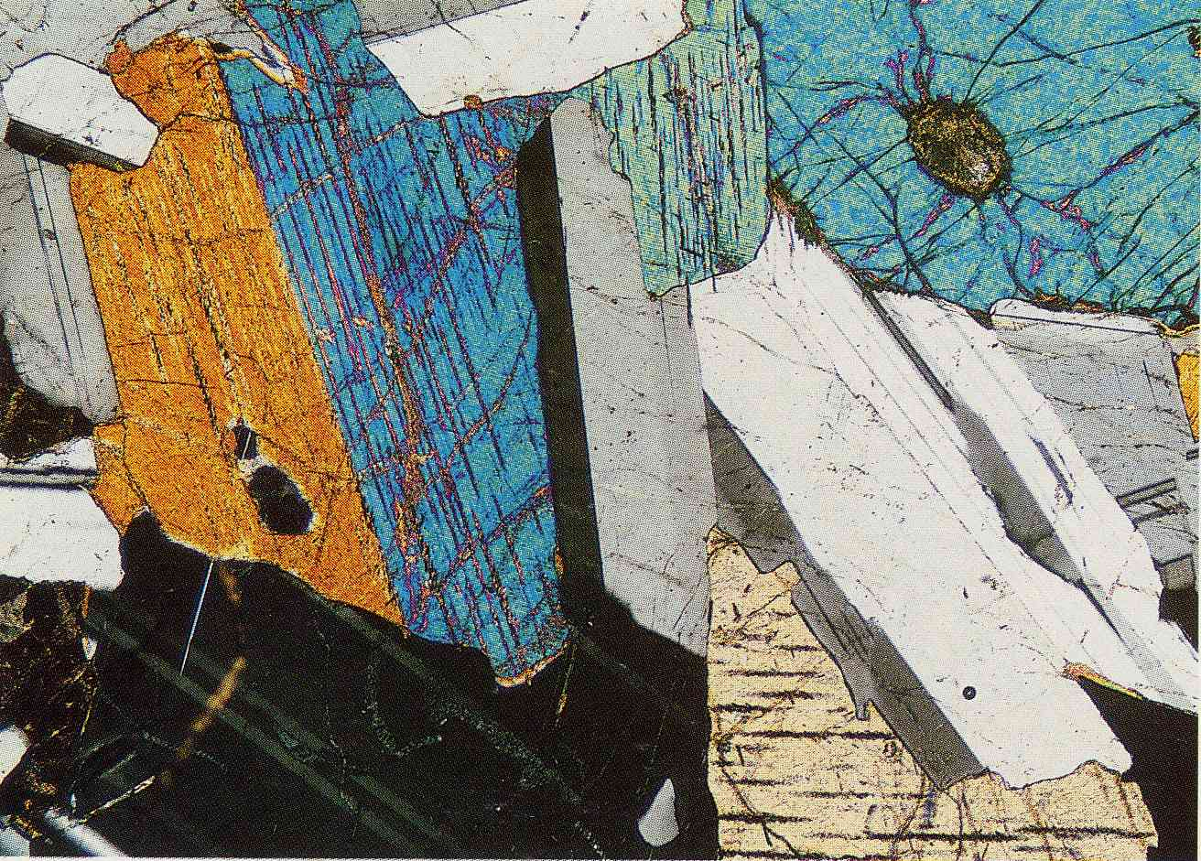

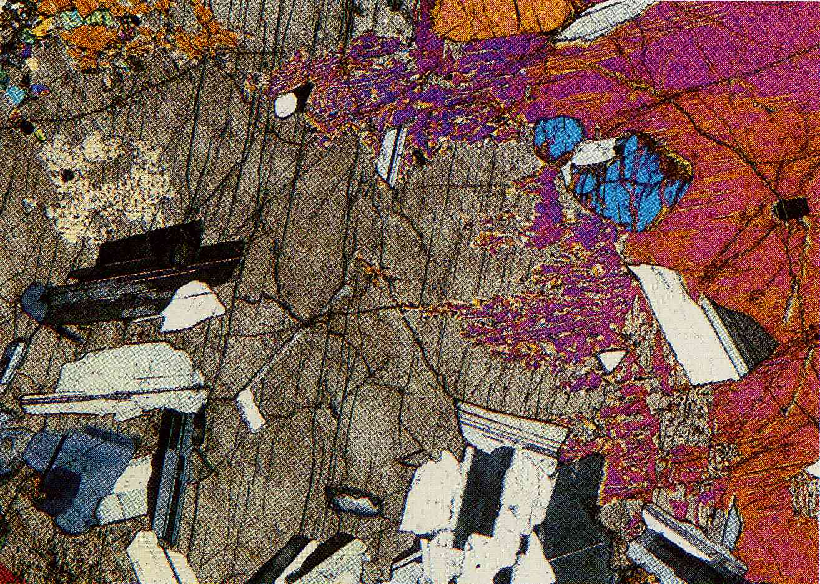
Orthopyroxene (centre) with low birefringence (low order grey) compared with clinopyroxene (upper right) with higher birefringence (2nd order pink and orange).

