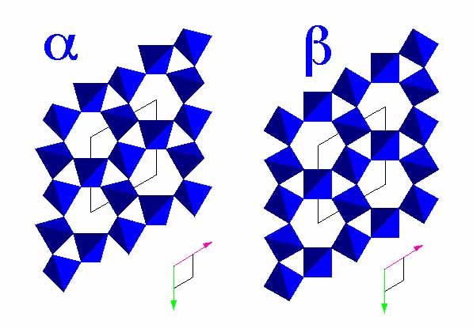
Tectosilicate

Quartz, SiO₂

There are several polymorphs of quartz. The most common one is “low-quartz” or “alpha-quartz” which crystallizes in class 32. A higher-temperature form, "beta-quartz", crystallizes in class 622. Both will be referred to as "quartz" during the laboratory exercises and mineral identification tests.

Diagnostic features: hardness (7: not scratched by knife), prismatic habit, conchoidal fracture, vitreous luster. Quartz always leaves a white streak, regardless of its colour (unless it contains inclusions of other minerals).

Habit: in euhedral (i.e. well-formed) crystals, the dominant form is generally a hexagonal prism with faces showing striations perpendicular to the c axis. The "pyramidal" ends are actually two rhombohedra (labelled “r” and “z” on these drawings). In anhedral (i.e. without faces) specimens, the lack of cleavage and hardness are characteristic.

Colour: highly variable, from transparent and colourless to black, with nearly every colour in between! Quartz is always very pure but minute amounts of certain impurities can give it vivid colours. Some colours can be modified by irradiation or heating because they are due to the presence of defects in the structure.

The names given to varieties of quartz having specific colours include: amethyst (purple), citrine (yellow), smoky quartz (dark brown), milky quartz (white). Chalcedony is a fibrous variety, often with a botryoidal habit.
