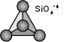Nesosilicate

Olivine (Mg,Fe)₂SiO₄

series: Forsterite Mg₂SiO₄ - Fayalite Fe₂SiO₄

(The use of parenthesis within a chemical formula indicates what elements may be found in variable proportions within a given mineral structure. In olivine, the silicate tetrahedra are connected by either Mg²⁺ or Fe²⁺ ions.)

Diagnostic features: hard (6.5-7: harder than knife) but grains are easily detached from the rock, making it difficult to test the real hardness. No cleavage but a pronounced conchoidal fracture. Colour is green but can tend towards yellow or brown. This mineral is found mostly in dark-coloured igneous rocks, such as the Hawaiian basalts. Unlike epidote, green olivine (forsterite) is not found with quartz.

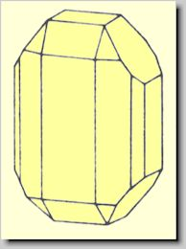
Colour: A perfectly pure forsterite would be colourless. The presence of some Fe²⁺ in most olivine is responsible for its green colour. Fe-poor varieties can be yellow, and Fe-rich varieties can be brown (if some of the Fe is Fe³⁺ rather than all Fe²⁺ ). A yellow-green variety of olivine is known as the gemstone PERIDOT.

Habit: stubby prismatic crystals (shorter than, and rarely striated like those of epidote).

