EPSC 210 Introduction to Mineralogy

Mid-term exam - October 17, 2002

Answer any four (4) of the five (5) questions. If you work on more than four questions, the four best answers will be graded. This exam counts either for 20% of your final grade, or it does not count at all if you do better on the final exam.

- Indicate if each statement is true or false, and briefly justify each answer.

- A triclinic crystal could not display a dipyramid unless it was pseudosymmetric.
True. A triclinic crystal has (at most) only a center of inversion, and has no rotation axis nor mirror plane. A dipyramid requires the presence (at least) of a mirror plane and a rotation axis.

- In class m m 2, the c axis is a polar axis and a mineral crystallizing in this class could be piezoelectric.
True, there is no mirror perpendicular to the 2-fold axis, so it can display a different looking face or form at either end. A polar axis is the condition for piezoelectricity.

- Andalusite (P 2/n 2/n 2/m), kyanite (P$\overline{1}$) and sillimanite (P 2/b 2/n 2/m) are pseudomorphs because they share the same chemical composition (Al₂SiO₅), and polymorphs because they have the same crystal forms.
False. The two terms are inverted. In a pseudomorph, a mineral has the same crystal forms as the mineral that it replaced or covered but not necessarily the same composition. Minerals polymorphs have the same composition but different structures (and therefore different space groups).

d) A pyramid is a variable form because its interfacial angles vary with its Miller indices.
The answer I was expecting is "true", because in a given mineral, different Miller indices such as (1 0 1) and (1 0 3) describe pyramids that differ in the steepness of their faces relative to the c axis. I gave partial marks for the answer "false" to students who pointed out that the same Miller indices (1 0 1) can refer to variable pyramids if they occur on minerals with different unit cell dimensions.

- Consider the four following space groups:

F 4 3 2₁ C c c 2 P 4/m 2₁/n 2/c P6₁

- translate each one to the corresponding crystal class and give its crystallographic system.
The answers, in order, are 4 3 2 (tetragonal), m m 2 (orthorhombic), 4/m 2/m 2/m (tetragonal) and 6 (hexagonal).

- which one of these space groups show(s) a center of inversion? P 4/m 2₁/n 2/c

- which one(s) of these space groups shows a glide plane perpendicular to a rotation axis? P 4/m 2₁/n 2/c
- which one of these space group would have a right (or left-)handed equivalent?
P6₁ has the enantiomorphic equivalent P6₅.

- which one includes a unit cell containing a total of 4 nodes? F 4 3 2₁

- Follow the instructions and build the following stereographic projection…
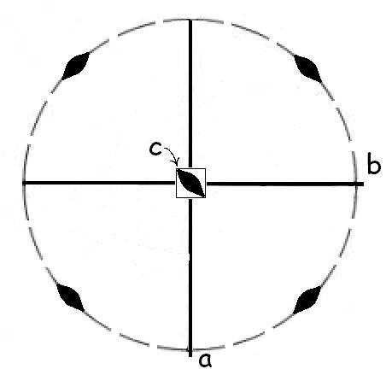
- sketch a stereogram showing the position of the symmetry elements of class $\overline{4}$ m 2
- indicate on the stereogram the orientation of axes a, b and c?

Answer to a, b, on the sketch, top left.

- show with dots (open or full) the position of the faces (1 0 1) and (1 0$\overline{1}$)
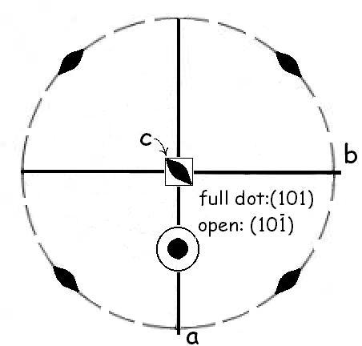
Answer on middle sketch. The two faces are superimposed as an open and a full circle.
- are these faces of the same kind (i.e. are they related by symmetry in that class)?
No, these two faces are not related ( because there is no mirror perpendicular to the $\overline{4}$-fold axis).
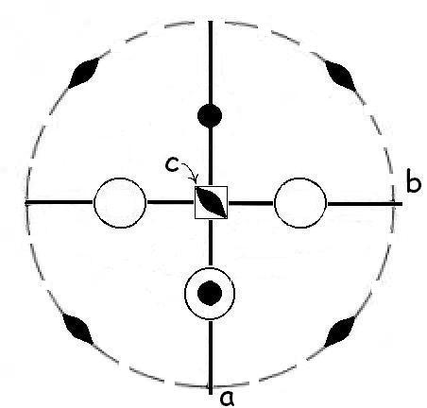
- plot on the stereogram other faces of {1 0 1} produced by the symmetry elements
Answer on the bottom left. The faces were simply added to the previous stereogram (and I left the (1 0$\overline{1}$) face in…)
- is {1 0 1} a pyramid or a dipyramid? How can you tell?
It is neither, because the rotoinversion produces four equivalent faces on both the upper and bottom part of the crystal, but they are not lined up as those of a dipyramid. (Not required in the answer: the {101} form is a a tetrahedron.)
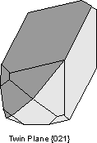
- Consider the sketches below. Any of them may be the answer to more than one of the questions.
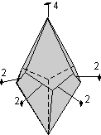
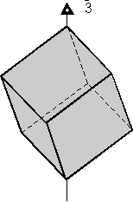
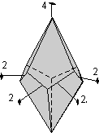
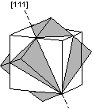
(I) (II) (III) (IV) (V)

(Note: in crystals II and III, the lower faces are not offset exactly halfway between the upper faces)

Which one(s) of the crystals above display(s)…

a)… a contact twin? Crystal (I)
b)… a center of inversion? Crystals I (possibly), IV, V
c)… either a right- or a left- handed screw axis? Crystals II, III
d)… a cubic habit? Crystals IV, V
e)… a cubic form? Crystal V

5. Define any three of the six terms listed below. In each case, illustrate your definition with a sketch.

rhombohedron closed form penetration twin
{1 2 1} isometric system prismatic cleavage

Examples of acceptable definitions:
- rhombohedron: form consisting of six faces of the same kind, related by a 3-fold rotoinversion axis (or observed in the hexagonal system).
- closed form: any form completely enclosing space, so that it could occur alone on a crystal.
- penetration twin: intergrowth of two crystals along a twin law
- { 1 2 1 }: set of faces of the same kind, related by symmetry, where one face, (1 2 1), intercepts the crystallographic axes at 1a, 1/2 b, 1c.
- isometric system: crystallographic system defined by three perpendicular axes with unit lengths a = b =c. [Could also be defined by the presence of four symmetrical 3-fold rotation (or rotoinversion) axes along the body diagonals of a cube.]
- prismatic cleavage: set of three or more planes of weakness that are parallel to a single axis of rotation in a crystalline structure,.

