EPSC 210 Introductory Mineralogy

Mid-term examination Thursday - October 8, 2009

Answer any four questions out of 5. Only the best answers will count towards your total grade. Each question has equal weight. This exam is worth 20% of your final grade but, if you do better on the final exam, this one won’t count.

Question 1. Is each of the following statement TRUE or FALSE? In each case, provide a brief explanation for your answer.

- a mineral crystallizing in the crystal class $\overline{1}$ has at least one polar axis and might be piezoelectric because it lacks a mirror plane.

- Being reconstructive, the transformation from high-quartz (P6₁22) to low-quartz (P3₁2) requires less time and a lower activation energy than the displacive transformation of kyanite (P$\overline{1}$, G=3.6) to sillimanite (Pbnm, G=3.23).

- Cooling a monoclinic orthoclase (C2/m) to a triclinic microcline (C$\overline{1}$) will give microcline the appearance of two interpenetrating crystals related by a 2-fold rotation axis.

- The pyramid {hkl} in class 4mm is a form that is variable and open.

Question 2. Follow the instructions and answer the questions.

a) Draw a stereogram showing the symmetry elements of the crystal class m m 2.

b) Show on the stereogram the position of the axes a, b and c.

c) Show by dots (full or open) the relative position of the faces (1 1 1) and (1 2 0) on the stereogram (assume that the unit length of a is about twice as large as that of b, and that the lengths of b and c are very similar.

d) Use the symmetry of this crystal class to find the position of other faces for the form {1 1 0}on the stereogram. Show all the faces of form {1 1 0} with full or open dots if appropriate, and give them Miller indices.

e) Is the form {1 1 1} a pyramid, a dipyramid or a prism? How can you tell?

Question 3. Two faces of the same kind occur on the same crystal. Coincidentally, the angle between their faces is 90°.
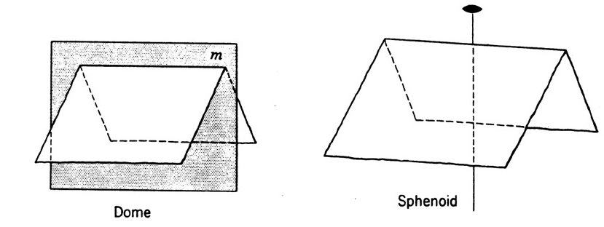

Question 3. (Note: Pick only one crystal in answer to each question. There may be more
than one possible answer, and the same drawing may be used for more than one answer.)
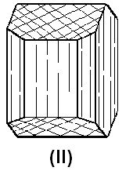
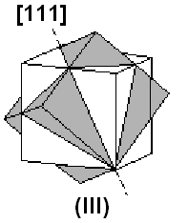
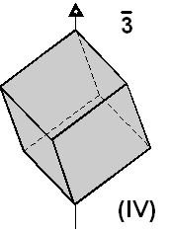
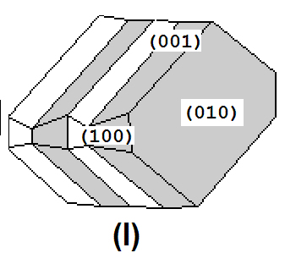

Which one of the drawings above (numbered I to IV) displays the feature mentioned below …

a) … at least two prisms (mark with a “p” the prismatic faces you see)

b)… a closed form

c) … an interpenetrating twin

d) … a crystal where the a and c axes are not perpendicular to each other (indicate on the drawing where you would place these axes

e) … an invariable form (mark with a “i” one face of the invariable form)

Question 5. Define any three ( and only 3) of the following six terms. Explain your answer with a sketch (even a bad one! I am not looking for artwork)…

unit cell variable form pseudomorph
twin law hexagonal system mineral

