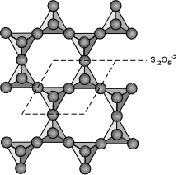
phyllosilicate

Lepidolite, K(Li, Al)₂₋₃(AlSi₃O₁₀)(O, OH, F) ₂

Diagnostic features: micaceous habit and cleavage; pink to lilac colour in thick books but colourless and transparent in thin sheets. Low hardness (2-2.5).

Habit: monoclinic, but euhedral crystals are rare and their cross-section is nearly rhombic or pseudo-hexagonal. Found most commonly in coarse to fine-grained scaly aggregates.

Occurrence: lepidolite is a relatively rare mineral, found in pegmatites, and usually associated with other lithium-bearing minerals such as pink and green tourmaline and spodumene.

