Abstract

Single crystals of diopside from the Orford Nickel Mine display zoning of Fe, Mg and Mn which correlates with the orientation of steps on the (100) face. The steps define hillocks, whose geometry provides evidence of differences in rate of layer spreading along non-equivalent crystallographic directions during crystal growth.

Introduction

Under certain growth conditions trace element incorporation in minerals has been shown, experimentally and from observations of natural specimens, to be influenced by surface structure in several minerals (and their synthetic equivalents). This can take the form of sector zoning, where non-equivalent faces display different affinities for the incorporation of certain elements (Dowty, 1976), or intrasectoral zoning where differential incorporation is induced on a single face by the presence of asymmetric steps that are part of growth spirals (Paquette and Reeder, 1990). The occurrence of sector zoning in pyroxene is well documented (list refs). We report here the first observation of intrasectoral zoning in a diopside

The specimens investigated were collected at the Orford nickel mine located in the Orford Township of southeastern Quebec. Although short-lived as a mining venture, the Orford nickel mine has a long history as a mineral collecting locality (Tarassoff and Gault, 1994). The vein exploited by the nickel mine was probably a large lens of calcite within a skarn-like calc-silicate. Textural features of the mineral assemblages and the carbonatization of ultramafic rocks of the footwall serpentinite are consistent with a hydrothermal origin for the Orford nickel deposit (Fortier, 1946; Gauthier, 1985; Gauthier, 1986a, Gauthier, 1986b, Gauthier et al., 1989). Subsequent brecciation and invasion by hydrothermal solutions deposited diopside, grossular and calcite in openings. The dump continues to yield millerite, grossular and diopside.

2. Method
The microtopography of the {100} face was investigated using a DimensionTM 3100 Series Scanning Probe Microscope atomic force microscope (AFM) in tapping mode. Growth hillock asymmetry was easily visible [in reflected light or only revealed by AFM?] on the vicinal faces.
The relative growth rates on the different types of steps can be estimated from the angles between the aretes separating the vicinal faces. Profiles perpendicular to the steps were obtained from the AFM images to compare step heights and spacings, and determine the slope of the non-equivalent vicinal faces. Two different methods in the AFM program were used to produce these sections: [state method finally used and describe… one of these sections needs to be included as figure.] The horizontal distance and vertical height were measured and a ratio calculated for each type of step.
The surface composition of this diopside crystal was first investigated on an unpolished as-grown (100) face in order to obtain an exact correlation of compositional zoning with the surface microtopography. Reflected light images of the surface of the crystal taken with the AFM allowed for precise selection of locations on the crystal for microprobe analysis. On one of the crystals examined, three hillocks were chosen for their low relief, so as to reduce the effect of topography on the accuracy of microprobe analyses. Semi-quantitative maps of each hillock were collected. Quantitative analyses were performed along three traverses across the different vicinal faces.
[state here info about electron microprobe: instrument type, method, standards, probe diameter, range of totals, (counting times?), (total number of analyses?), etc]

The standards used were albite for Na, diopside for Mg, Ca and Si, chromite for Cr, hematite for Fe, orthoclase for Al and spessartine for Mn. [detection limits for these elements?]

The probe diameter was 5 μm [check units]. Operated at 15 kV via wavelength-dispersion spectrometry (WDS).

The total weight percents for all analyses ranged from 94.527 (or 96.034?) to 98.308 wt%, with an average of 97.362 (without 94.527, average: 97.397)

Judging from the plot I made and the image, the 94.527 point looks like it wasn’t even on the hillock with the others. Does this mean we can discount it then?

3. Results

The diopside crystals investigated are light yellow and translucent. Some consist of aggregates in parallel growth. Their habit, bladed and flattened on the (100) faces, is relatively uncommon for diopside but characteristic of the Orford nickel mine (Tarassoff and Gault, 1994). The (100) faces are vitreous and covered with shallow growth pyramids consisting of four vicinal faces, often visible to the naked eye. The other faces are striated, dominantly along the c axis of the crystal.

3.1 Surface microtopography on (100)
The AFM images show that three different types of steps make up these growth hillocks, a geometry of the growth hillocks is consistent with the face symmetry of (100). Steps growing parallel to [001] were symmetrical and relatively straight. The steps aligned parallel to [010] are distinctly wavy, and the two sets spreading in opposite directions tend to show different wavelengths. Their relationship to the face symmetry of (100) indicates that they are nonequivalent; we refer to them as [010]⁺ and [010]⁻ steps in order to distinguish them (Figure 4).
[We try to avoid repeating directly the figure captions in the text… Instead, we refer to the figures to complement a description. Eliminate the following if it is contained in the figure captions. Figure ? shows the meeting of the straight steps parallel to [001] along a boundary with the crinkly [010]⁺ steps. Figure ? is an image of the meeting of the [001] steps with the [010]⁻ direction steps.]
The [010]⁺ steps are wavy. [are the wavelengths consistent from crystal to crystal? 6 images, 64 measurements]. the waves appear to be lined up and in phase with each other. Measurement taken from four images (always same crystal?) that included these types of steps showed that, although the wavelengths were variable from hillock to hillock, they stayed within an average range of about 1.5 um. The wavelength of the [010]⁻ steps is longer and more variable, and the undulations are generally out of phase with each other. Measurements taken from two images of these steps showed an average range of about 4.6 um within a single hillock. [I’m sure this isn’t worded very well...I’ll try to fix it later.]

diopa01.013
[010]+ step wavelengths in um
Step 1 | Step 2 | Step 3 | Step 4 | Step 5 | Step 6 | Step 7 | Step 8 | Step 9 | Step 10 | Step 11
3.008 | 2.695 | 3.164 | 2.422 | 3.203 | 2.891 | 2.461 | 3.594 | 3.516 | 2.930 | 3.242
4.297 | 2.813 | 3.867 | 3.867 | 3.711 | 2.734 | 3.906 | 2.656 | 3.320 | 3.906 | 2.813
3.32 | 2.852 |  |  | 3.789 |  | 2.383 |  | 3.242 | 3.945
diopa01.028
[010]+ step wavelengths in um
Step 1 | Step 2 | Step 3
3.711 | 2.617 | 2.277
3.750 | 3.438 | 2.383
diopa01.031
[010]+ step wavelengths in um
Step 1 | Step 2 | Step 3 | Step 4
4.336 | 4.531 | 5.156 | 5.547
4.141 | 4.648 | 5.781
diopa01.039
[010]+ step wavelengths in um
Step 1 | Step 2
1.680 | 1.680
2.656 | 2.266
2.031
2.148
2.266
1.992
diopa01.040
[010]- step wavelengths in um
Step 1 | Step 2 | Step 3 | Step 4 | Step 5
3.633 | 4.531 | 8.594 | 6.055 | 8.555
6.406 | 3.711
 | 4.570
diopa01.037
[010]- step wavelengths in um
Step 1 | Step 2 | Step 3
5.742 | 4.141 | 7.305
2.969 | 3.828 | 7.148
3.164

The boundary between the step directions in [both images… your description should reflect your observations of far many more images than only these two, so mention how many you collected from] is irregular. The angle between the step directions tends to shift from 45º, reflecting differences in their relative growth rates. [measure actual angles] It is possible to tell the relative magnitude of the growth rates from the angle between the aretes of vicinal faces. Using this relationship (we can quantitative: it's a simple trigonometric construction that we should do, so that we translate your angular measurements into a range of relative rates), the steps in the [010] direction generally grew [how much?] faster than those in the [001] direction.

  - Trace element incorporation
The semi-quantitative maps of Si, Mg, Ca and Fe for the three chosen locations (Figure 9, Figure 10, Figure 11) showed slight but definite differences in the concentrations of Fe and an opposite relationship to Mg concentrations for non-equivalent vicinal faces. These results were encouraging and quantitative analyses of Na₂O, MgO, Cr₂O₃, CaO, SiO₂, Al₂O₃ and MnO performed on specific points on four different hillocks showed that there was a difference in Mn and Fe in their concentrations along different step directions. Fe showed the highest concentration along the [010]⁺ steps and the lowest concentration along the [010]⁻ steps. The [001] steps seemed to have intermediate concentrations. The concentration of Mg did not seem to exhibit any particular pattern with respect to step direction.
[Mention this one first] The first hillock (Table 1) was analyzed on all its four vicinal faces. As before, the [010]⁺ steps exhibited the highest concentrations of FeO (7.09-7.28 wt%) and MnO (0.47-0.52 wt%). The [001]⁻ steps were intermediate, showing concentrations of 6.74-6.89 wt% FeO and 0.423-0.452 wt% MnO. The lowest concentrations in both elements were in the [010]⁻ steps (6.61-6.78 wt% FeO, 0.40-0.42 wt% MnO). The [001]⁺ steps also exhibited intermediate concentrations of FeO (6.75-6.84 wt%), but had lower concentrations of MnO (0.406-0.423 wt%) more comparable to those of the [010]⁻ steps.
Analysis of other hillocks only included vicinal faces formed by the [010]⁺ and [001] steps (Tables 2 and 3), but they confirmed the relationships demonstrated on the first hillock. Table 2 shows a slight but consistent difference in FeO and MnO concentration as the traverse crossed the contact between the two types of vicinal faces. On one hillock, the [001] steps had a FeO range of 6.60-6.72 wt% and MnO of 0.38-0.40 wt% . The [010]⁺ steps had higher concentrations, FeO being 6.74-7.00 wt%, and MnO being 0.40-0.46 wt%.
The data shown in Table 3 were taken from only the [001] steps of hillocks 3 and 4. The weight percent ranges of FeO and MnO show a narrow range and the variations show no systematic pattern (approximately 6.5-6.7 wt% of FeO and 0.38-0.41 wt% of MnO). The data show that [001] vicinals of hillocks 3 and 4 have compositions comparable to those of hillock 1, but lower FeO and MnO concentrations than those of hillock 2.
There were overall differences between the relative high, intermediate and low concentrations between the four hillocks. The FeO concentrations in the [001] vicinals of hillocks 3 and 4 were lower than those of hillock 1, while the MnO concentrations were similar. Hillock 1 exhibited the highest concentrations in every step direction, reflecting possible variations in incorporation between hillocks as well as step directions. Despite these differences, the pattern is that concentrations of both FeO and MnO are the greatest along the [010]⁺ steps, intermediate along the [001] steps, and the least along the [010]⁻ steps.
[It might be possible to consolidate them in a single table.]
A potential of variations among hillocks is concentric zoning, particularly if not all the areas analyzed represent the same time interval of the growth history. It is possible that growth proceeded slightly longer on part of the surface than on others, and that the latest concentric zone might be discontinuous across the surface. In order to evaluate the importance of concentric zoning, the (100) face was polished flat and a semi-quantitative map of the entire crystal was collected by back-scattered electron imaging. [Insert your description of the concentric zones: how wide (or variable in width) are they, how continuous, etc. Do they wrap, partly or completely around some areas near the center of the crystal?]
Concentric zoning was found throughout the crystal but was more visible near the edges. The zones are of variable width and show differences in iron concentration. They are continuous but do not wrap all the way around the crystal. The zones are bent but only rarely do they appear to encircle any features such as hillocks or surface irregularities. The uneven pattern of the zoning suggests that the polishing procedure cut into the crystal at a small angle. Measurements of these zones yielded only apparent widths that ranged from about 10μm to 327μm, with an average of approximately 73μm. Due to the large range of sizes of hillocks (200μm to 2mm) on this crystal, the bending of the zones may be due to hillocks.
The mottling seen in the center of the hillock may represent differing concentrations of iron along different hillocks.

[Polishing parallel to a former growth surface also provided a section through adjacent growth sectors and through another crystal grown parallel to the main one. We may skip this if it doesn't add any new information.] The concentric zones shown in this parallel crystal allowed for measurements of the actual widths of the zones. The average width was approximately 164μm.

Bibliography
References

Adam, Green, Sie, Ryan (1997) Trace element partitioning between aqueous fluids, silicate melts and minerals. European Journal of Mineralogy, 9, 569-584. [Check this one out to see if anything is said about disequilibrium partitioning...]

Carpenter, M.A. (1980) Composition and cation order variations in a sector-zoned blueschist pyroxene. Am. Min. 65, 313-320.

Nakamura, Y. (1973) Origin of sector-zoning in igneous clinopyroxenes. American Mineralogist., 58, 986-990.

Philippot, P. and Kienast, J.-R. (1989) Chemical microstructural changes in eclogite facies shear zones (Monviso, Western Alps, North Italy) as indicators of strain history and the mechanism and scale of mass transfer. Lithos 23, 179-200.
Partitioning of elements in sector-zoned clinopyroxenes
Jensen BB. In: MINERALOGICAL MAGAZINE 64 (4): 725-728 AUG 2000

HIGH-PRESSURE EXPERIMENTAL TRACE-ELEMENT PARTITIONING BETWEEN CLINOPYROXENE AND BASALTIC MELTS
SKULSKI T, MINARIK W, WATSON EB
CHEMICAL GEOLOGY 117 (1-4): 127-147 NOV 1 1994

Abstract:

Clinopyroxenes play an important role in determining the distribution of trace elements in magmatic systems. In order to evaluate the extent and source of variation of clinopyroxene-silicate melt partition coefficients (D), experiments were conducted on natural basalts (picrite, alkaline basalt, nephelinite, high-alumina basalt; 1235-1300 degrees C; 1-2.8 GPa) doped with a multi-element spike (Ti, Cr, V, Sr, Y, Zr,
Nb, Ta, Hf, La, Ce, Nd, Sm, Dy and Yb) and water (2%). Trace-metal concentrations were determined by synchrotron XRF (SXRF) microprobe and a subset of samples were analyzed by SXRF superconducting wiggler and ion microprobe (IMP). Mid-range D-values (by IMP) for clinopyroxene in a picritic starting composition at 1300 degrees C and 1 GPa are: D-Ti, 0.273; D-V, 2.77; D-Cr, 7.32; D-Sr, 0.079; D-y, 0.376; D-Zr 0.089; D-Nb, 0.003; D-Hf 0.179; D-Ta, 0.010; D-La, 0.03; D-Ce, 0.054; D-Nd, 0.112; D-Sm, 0.201; D-Dy, 0.280; and D-Yb, 0.255. D-values for Ta and Zr are lower than adjacent D-values for REE (La and Nd, respectively) on a spider diagram; however, there is no decoupling observed between D-Ti, D-Hf and adjacent D-REE (D-Y,D-Yb).

Many of the experiments resulted in sector-zoned augite, and these constrain the nature of crystal chemical controls on partitioning at fixed T,P,X. Sector-zoned augite in an alkaline basalt at 1250 degrees C and 1 GPa shows enrichment in Ti, Al, Ca, Cr, trace HFSE and REE and depletion in Si, Mg and Fe in the fast-growing (100) sector relative to the slower growing (010) sector. Reverse-zoning in incompatible
elements in the (100) sector adjacent to normally-zoned (010) sectors confirms that sector zoning in augite arises from differences in surface kinetic processes (adsorption-desorption) during crystal growth. A positive correlation between Al-IV and HFSE concentrations emphasizes the importance of coupled substitution involving highly charged cations in M sites and Al in T sites.

KeyWords Plus:
ION MICROPROBE, AUGITE PHENOCRYSTS, SILICATE MELTS, UPPER MANTLE, COEFFICIENTS, XENOLITHS, LIQUID, ORIGIN, EQUILIBRIUM, PYROXENE

A simple model for sector zoning in slowly grown crystals: Implications for growth rate and lattice diffusion, with emphasis on accessory minerals in crustal rocks
Watson EB, Liang Y
AMERICAN MINERALOGIST 80 (11-12): 1179-1187 NOV-DEC 1995

Abstract:
The occurrence of sector zoning in minerals of regional metamorphic or low-temperature intrusive origin implies that rapid growth is not required for the development of this particular form of homogeneous disequilibrium. It is shown here that sector zoning can be a natural consequence simply of slow lattice diffusion. Given anisotropic surface enrichment coupled with the low diffusivities typical of highly charged
elements in refractory accessory minerals such as zircon and titanite, sector zoning can arise even in cases of growth rates as low as a few micrometers per million years. According to the proposed model, the development of sector zoning depends upon the competition between growth rate (V) and lattice diffusion (D-i) within the near-surface layer (l), such that above a critical value of Vl/D-i (similar to 0.5-3), sector
zoning is unavoidable in crystals that exhibit selective enrichment on some growth surfaces. Known diffusivities of rare earth elements in zircon and titanite lead to the expectation of sector zoning in these minerals with respect to REEs for reasonable geologic growth rates. Even in the case of clinopyroxene, diffusion of REEs and high field-strength elements may be slow enough to contribute to the development of sector zoning in laboratory-grown crystals.

KeyWords Plus:
PETROGENETIC SIGNIFICANCE, TRACE-ELEMENTS, CLINOPYROXENES, STRONTIUM, ZIRCONS, ORIGIN

Sector-zoned augite megacrysts in Aleutian high alumina basalts: implications for the conditions of basalt crystallization and the generation of calc-alkaline series magmas
Brophy JG, Whittington CS, Park YR
CONTRIBUTIONS TO MINERALOGY AND PETROLOGY 135 (2-3): 277-290 MAY 1999

Abstract:
Several high alumina basalts from the Aleutian volcanic centers of Cold Bay and Kanaga Island contain large (up to 1.5 cm diameter) megacrysts of sector-zoned augite. The megacrysts are invariably euhedral with well developed {001}, {010} and {111} forms. All crystals display concentric bands that are rich in mineral and glass inclusions. The sector zonation typically occurs as well developed (010), (100), (111) and (110) sectors which grew at different rates. A comparison of the width of synchronous growth bands indicates that following relative growth rates: (111)much greater than(100) similar to (110) > (010). Compositionally, SiO2 and MgO abundances decrease, and TiO2, Al2O3, FeO and Na2O abundances increase in the different sectors in the order (111), (100) similar to (110), (010). This order is identical to that deduced for the relative growth rates, implying that growth rate clearly had a role in the development of the sector zonation.
Calculated pre-eruption H2O contents of the basalts range from 1 to 3 wt% but actual (measured) post-eruption H2O contents range from 0.01 to 0.3 wt%. Deteurium isotopic values are heavily depleted and range from -110 to -141 parts per thousand. Together these indicate significant vapor (H2O) exsolution prior to eruption. Maximum H2O abundances in primitive glass inclusions, thought to be most representative of the host liquid reservoir at the time of melt entrapment, systematically decrease from the core to the rim of one augite megacryst studied in detail. We conclude that the presence of sector-zoned augite is due to augite supersaturation and rapid crystallization brought about by magma decompression and volatile (H2O) exsolution. The calculated pre-eruption H2O contents of 1-3 wt% limit vapor
exsolution and basalt crystallization to depths of less than 3 and more likely 1.5 km. Very rapid crystallization at very shallow depths makes it unlikely that the time scales between initial crystallization and final eruption are sufficient to permit appreciable amounts of fractional crystallization. Given that high alumina basalt fractionation is the dominant process for generating more evolved andesite, dacite and rhyolite magmas of the calc-alkaline suite, the inability of parental high alumina basalt to yield such derivative magmas in the low pressure environment places the likely site of fractionation in the high pressure environment, at or near the base of the crust.

KeyWords Plus:
MEDICINE LAKE VOLCANO, EXPLOSIVE ERUPTIONS, SOUTH GREENLAND, MASS-TRANSFER, ARC, INTRUSION, ISLAND, ORIGIN, FRACTIONATION, INCLUSIONS

Surface enrichment and trace-element uptake during crystal growth
Watson EB
GEOCHIMICA ET COSMOCHIMICA ACTA
60 (24): 5013-5020 DEC 1996

Abstract:
Adsorption or enrichment of trace elements in the near-surface or interfacial regions of minerals has been documented in systems ranging from low-temperature aqueous environments to magmas. Under static conditions, this surface enrichment results from chemical equilibrium between the host medium of the crystal and the surface layer, which may exhibit diversity or flexibility in the types of atomic sites present. If the crystal is growing, any trace elements bound in the surface layer may be buried and trapped in the newly-formed lattice, resulting in lattice concentrations that deviate substantially from those predicted by equilibrium partitioning between the crystal and its growth medium. The effectiveness of this growth entrapment process depends upon the interplay between the growth rate, V, of the crystal (which can be thought of as the burial rate of surface-enriched element i) and the diffusivity, D-i, in the near-surface region of the crystal (which determines how efficiently i can escape to the surface by diffusion). The competition can be quantified in terms of the dimensionless number Vl/D-i (termed the growth Peclet number, Pe), where I is the half-thickness of the surface-enriched layer. Depending upon the degree of surface enrichment, some growth entrapment is possible if Pe > 0.1, and the process is highly efficient if Pe > 10. An assessment of Pe for a wide variety of geological situations suggests that growth entrapment is common in diagenetic and metamorphic environments but limited to slow lattice diffusants in silicic igneous systems. It is probably rare to nonexistent in basaltic systems except at laboratory growth rates.

KeyWords Plus:
SIZE DISTRIBUTION CSD, RUTHERFORD BACKSCATTERING SPECTROSCOPY, PARTITION-COEFFICIENTS, STRONTIUM DIFFUSION, WATER INTERFACES, GRAIN-BOUNDARIES, OXYGEN ISOTOPES, CRYSTALLIZATION, DISEQUILIBRIUM, CALCITE

LABORATORY GROWTH OF SECTOR ZONED CLINOPYROXENES IN THE SYSTEM CAMGSI2O6-CATIAL2O6
KOUCHI A, SUGAWARA Y, KASHIMA K, SUNAGAWA I
CONTRIBUTIONS TO MINERALOGY AND PETROLOGY 83 (1-2): 177-184 1983

Kinetics of clinopyroxene growth from a hydrous hawaiite melt
Simakin AG, Salova TP, Armienti P
GEOCHEMISTRY INTERNATIONAL
41 (12): 1165-1175 DEC 2003

Abstract:
Melting phase relations were studied for a hawaiitic composition with 2.4 +/- 0.1 wt % water under a pressure of 600 bar and oxygen fugacity near the Ni-NiO buffer. These conditions correspond to the degassing and eruption of Etna Volcano, Sicily. The experimental liquidus temperatures of olivine (1120degreesC) and clinopyroxene (1105degreesC) are in agreement with the values calculated by the
MELTS software package. The growth rates of olivine and clinopyroxene were estimated by the quench method using forsterite and diopside seeds. At an undercooling of DeltaT= 25 +/- 5 K, lathlike clinopyroxene grew at a rate of (2.0-2.5) x 10(-5) cm/s and contained 6.5-8.5 wt % Al-O-2(3). Under similar conditions, diopside seeds are evenly overgrown at an order of magnitude lower rate, (2-3) x 10(-6)
cm/s. At DeltaT approximate to 5 K (T = 1100degreesC), diopside seeds are evenly overgrown with the formation of growth steps on the surface of crystals. The growth rate of olivine is low, 7 x 10(-7) cm/s at 1075degreesC (DeltaT = 45 +/- 5 K). This is consistent with the small amount of olivine forming during cooling of hydrous hawaiite melt calculated by the MELTS program.

KeyWords Plus:
MT-ETNA, CRYSTAL-GROWTH, SILICATE MELTS, WATER-CONTENT, SYSTEM, CRYSTALLIZATION, EQUILIBRIA,
ERUPTION, MODEL, NUCLEATION

NATURAL CRYSTALLIZATION AND RELEVANT CRYSTAL-GROWTH EXPERIMENTS
BARONNET A
PROGRESS IN CRYSTAL GROWTH AND CHARACTERIZATION OF MATERIALS 26: 1-24 1993

Abstract:
Inorganic crystallization conditions of rocks from the earth's crust are briefly reviewed. Then a comparison is made between these natural processes of growth and the classical methods used by crystal growers. Finally, it is shown that dynamic crystallization experiments of silicates mimic qualitatively well natural growth processes but also that quantitative data from these remain hardly transposable.

KeyWords Plus:
PHLOGOPITE SINGLE-CRYSTALS, SILICATE MELTS, HYDROTHERMAL GROWTH, NUCLEATION, KINETICS, MAKAOPUHI, ANORTHITE, DIOPSIDE, MAGMAS

THE ROLE OF TRANSITION ELEMENT ADSORPTION ON GROWTH-KINETICS OF THE PHLOGOPITE MICA
SUN BN, BARONNET A
CHEMICAL GEOLOGY 70 (1-2): 82-82 AUG 1 1988

HYDROTHERMAL GROWTH OF OH-PHLOGOPITE SINGLE-CRYSTALS .2. ROLE OF CR AND TI ADSORPTION ON CRYSTAL-GROWTH RATES
SUN BN, BARONNET A CHEMICAL GEOLOGY 78 (3-4): 301-314 DEC 15 1989

Figure captions

Figure 3. A-D: AFM topographic maps collected from different hillocks.

Figure 3. A) Optical photomicrograph of a single growth hillock showing the trace of electron probe microanalyses (spots) along 5 traverses. The higher macrosteps are faintly visible as are the boundaries between adjacent vicinal faces (red). The orientation of the hillock is the same as in Figure 2. Line 1 is from vicinal face [010]+, lines 2-3 from [001]+/-, and lines 4-5 from [010]-. B) Line drawing of the same hillock showing the orientation of some macrosteps and boundaries between vicinal faces.

Figure 4. Electron microprobe data from the vicinal faces of the hillock shown in Figure 3A. The analyses are grouped by traverses numbered 1 to 5 as on Figure 3B. A) FeO concentrations shows the largest absolute differences. Line1 is from the vicinal face [uvw]. Lines 2-3, from the symmetry-equivalent vicinal faces [uvw] show similar FeO concentrations. Lines 4-5, from the vicinal face [uvw] are slightly less Fe-rich than other vicinal faces. B) MnO concentrations are also highest on vicinal face [uvw] but differences between other vicinal faces are less pronounced.
Figure 1: SHAPE drawing of the crystal morphology of diopside from the Orford nickel mine. The c axis is vertical and the b axis runs approximately E-W along the second largest edge of the crystal.

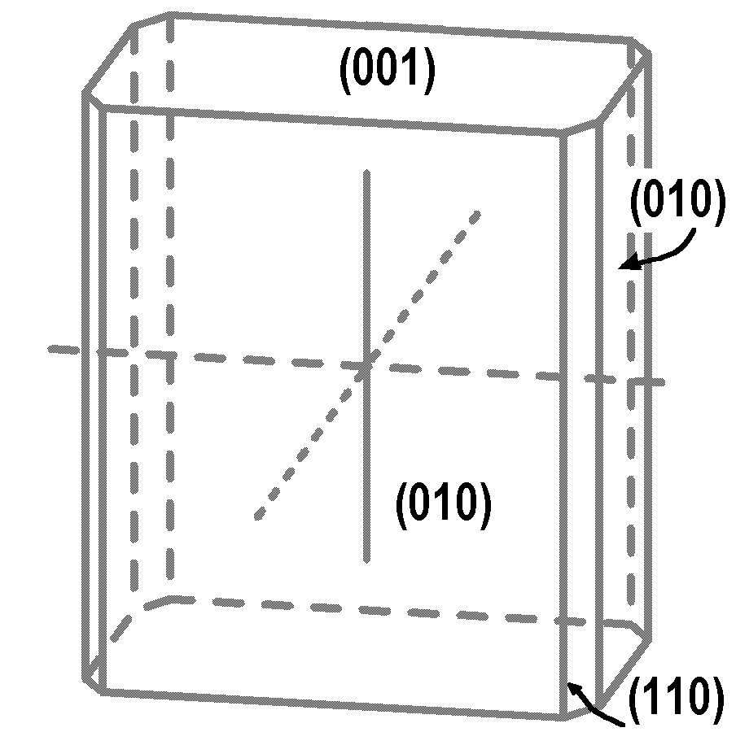

Figure 2. Center: Schematic view of a single growth hillock on the (100) face. The four vicinal faces are defined by three types of non-equivalent steps. Each vicinal face is labelled after its dominant step orientation [uvw]. The “+” and “-” superscripts indicate opposite directions of layer spreading during growth.The shaded vicinal faces formed by arrays of straight [001]⁺ and [001]⁻ steps are related by a mirror plane, unlike the vicinal faces formed by undulating steps [010]⁺ and [010]⁻.
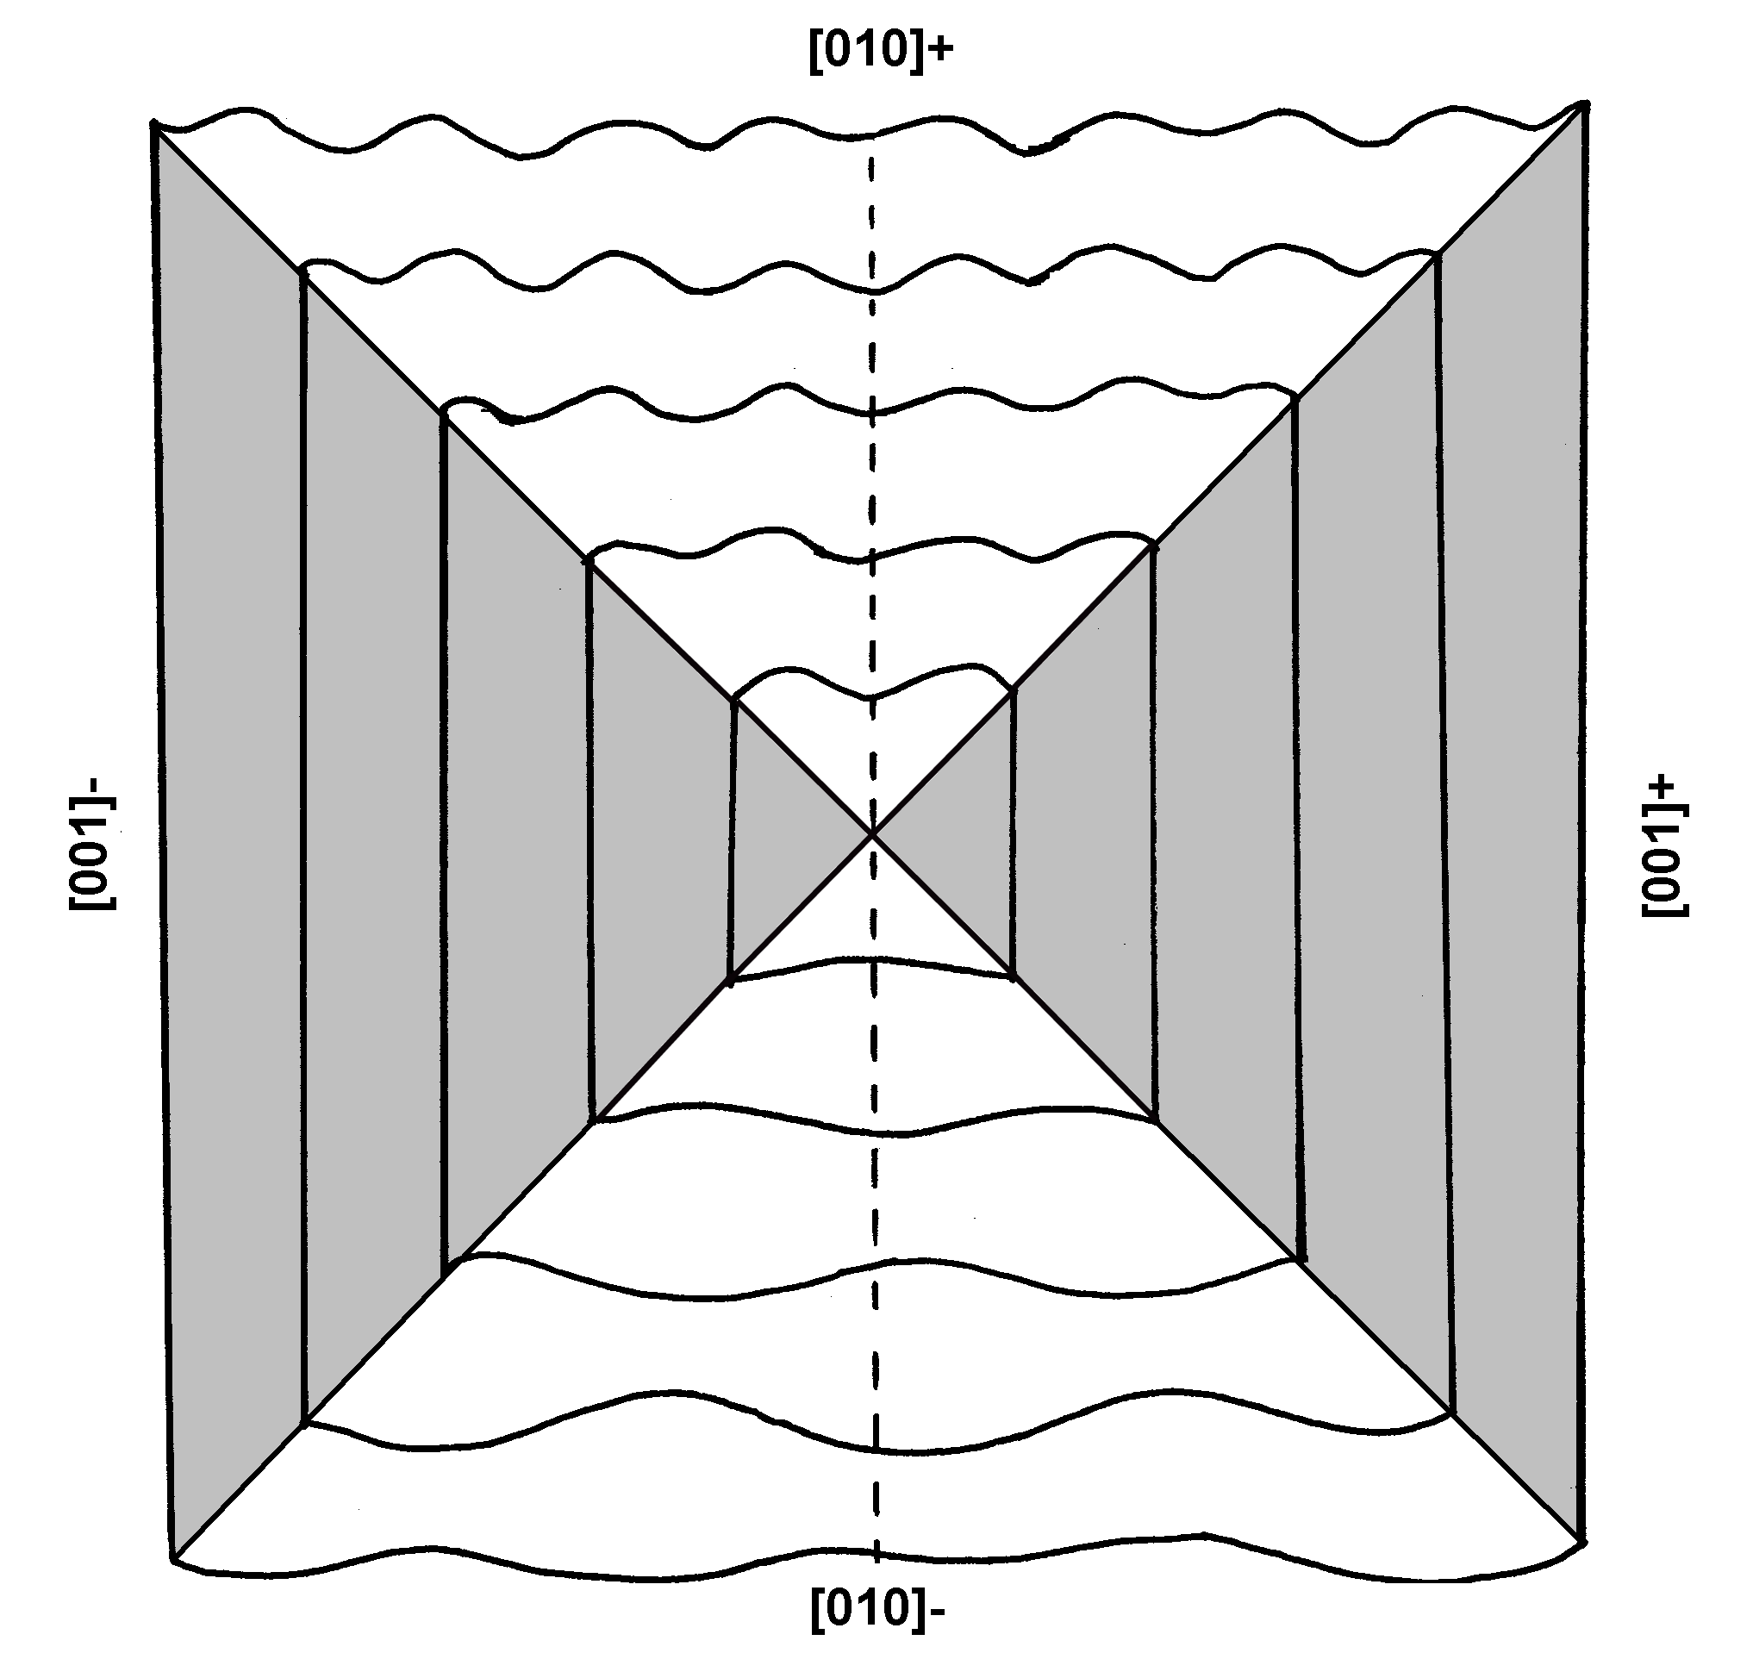
Figure 3. AFM topographic maps collected from different hillocks, showing the different types of steps observed on the (010) face. A) corner defined by straight steps [001]⁻ and the wavy steps [010]⁺. B) corner defined by straight steps [001]⁻ and the slightly undulating steps [010] ⁺. The different aspect of the steps on vicinal faces [010] ⁻ and [010] ⁺ is consistent with the fact that they are not related by the face symmetry.
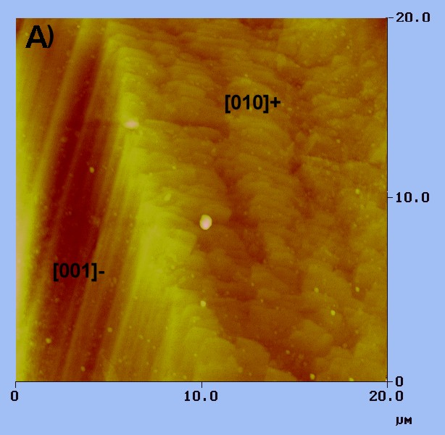
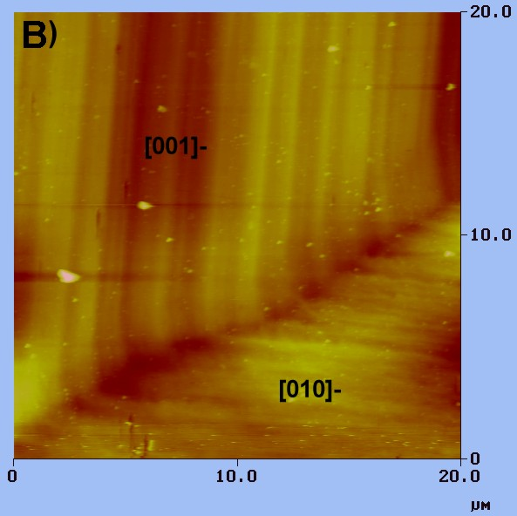

Figure 4. Electron microprobe data from the vicinal faces of the hillock shown in Figure 3A. The analyses are grouped by traverses numbered 1 to 5 as on Figure 3B. A) FeO concentrations shows the largest absolute differences. Line1 is from the vicinal face [uvw]. Lines 2-3, from the symmetry-equivalent vicinal faces [uvw] show similar FeO concentrations. Lines 4-5, from the vicinal face [uvw] are slightly less Fe-rich than other vicinal faces. B) MnO concentrations are also highest on vicinal face [uvw] but differences between other vicinal faces are less pronounced.

Table 1
Microprobe data: Hillock 1
Label | Point | Step type | Na2O | MgO | Cr2O3 | CaO | *FeO | SiO2 | Al2O3 | *MnO | Total
Line 1 | 1 | [010]+ | 0.041 | 12.808 | 0 | 24.456 | 7.217 | 52.20 | 0.073 | 0.519 | 97.314
Line 1 | 2 | [010]+ | 0.027 | 12.76 | 0 | 24.511 | 7.212 | 52.372 | 0.057 | 0.509 | 97.448
Line 1 | 3 | [010]+ | 0.043 | 12.906 | 0.03 | 24.433 | 7.217 | 52.428 | 0.054 | 0.506 | 97.617
Line 1 | 4 | [010]+ | 0.042 | 13.103 | 0 | 24.480 | 7.277 | 52.225 | 0.069 | 0.498 | 97.694
Line 1 | 5 | [010]+ | 0.049 | 13.053 | 0.022 | 24.370 | 7.244 | 52.388 | 0.072 | 0.487 | 97.685
Line 1 | 6 | [010]+ | 0.058 | 12.861 | 0 | 24.595 | 7.214 | 52.529 | 0.068 | 0.49 | 97.815
Line 1 | 7 | [010]+ | 0.057 | 13.026 | 0.039 | 24.355 | 7.145 | 52.594 | 0.065 | 0.484 | 97.765
Line 1 | 8 | [010]+ | 0.041 | 13.155 | 0.006 | 24.568 | 7.108 | 52.646 | 0.09 | 0.485 | 98.099
Line 1 | 9 | [010]+ | 0.051 | 13.024 | 0.004 | 24.477 | 7.088 | 53.121 | 0.077 | 0.466 | 98.308
Line 1 | 10 | [010]+ | 0.056 | 13.118 | 0 | 24.355 | 7.118 | 52.804 | 0.085 | 0.485 | 98.021
Line 2 | 1 | [001]- | 0.021 | 13.107 | 0 | 24.327 | 6.848 | 52.379 | 0.085 | 0.435 | 97.202
Line 2 | 2 | [001]- | 0.058 | 13.051 | 0.006 | 24.601 | 6.763 | 52.386 | 0.071 | 0.432 | 97.368
Line 2 | 3 | [001]- | 0.045 | 13.089 | 0 | 24.433 | 6.836 | 52.346 | 0.073 | 0.423 | 97.245
Line 2 | 4 | [001]- | 0.022 | 12.969 | 0 | 24.362 | 6.857 | 52.246 | 0.065 | 0.424 | 96.945
Line 2 | 5 | [001]- | 0.031 | 13.267 | 0.001 | 24.299 | 6.892 | 52.38 | 0.065 | 0.452 | 97.387
Line 2 | 6 | [001]- | 0.032 | 12.994 | 0 | 24.573 | 6.879 | 52.085 | 0.061 | 0.438 | 97.062
Line 3 | 1 | [001]+ | 0.050 | 13.283 | 0 | 24.344 | 6.746 | 52.209 | 0.088 | 0.415 | 97.135
Line 3 | 2 | [001]+ | 0.062 | 13.364 | 0.009 | 24.456 | 6.828 | 52.27 | 0.086 | 0.41 | 97.485
Line 3 | 3 | [001]+ | 0.063 | 13.214 | 0 | 24.500 | 6.833 | 52.381 | 0.065 | 0.423 | 97.479
Line 3 | 4 | [001]+ | 0.051 | 13.206 | 0.006 | 24.729 | 6.803 | 52.288 | 0.086 | 0.409 | 97.578
Line 3 | 5 | [001]+ | 0.051 | 13.165 | 0.036 | 24.228 | 6.841 | 52.202 | 0.077 | 0.41 | 97.01
Line 3 | 6 | [001]+ | 0.063 | 13.211 | 0.01 | 24.613 | 6.814 | 52.425 | 0.066 | 0.406 | 97.608
Line 4 | 1 | [010]- | 0.041 | 13.238 | 0 | 24.348 | 6.749 | 52.188 | 0.087 | 0.407 | 97.058
Line 4 | 2 | [010]- | 0.044 | 13.134 | 0 | 24.591 | 6.778 | 52.391 | 0.089 | 0.419 | 97.446
Line 4 | 3 | [010]- | 0.052 | 13.048 | 0 | 24.616 | 6.691 | 52.355 | 0.068 | 0.417 | 97.247
Line 4 | 4 | [010]- | 0.058 | 13.235 | 0.017 | 24.710 | 6.692 | 52.085 | 0.087 | 0.413 | 97.297
Line 4 | 5 | [010]- | 0.025 | 13.199 | 0 | 24.585 | 6.715 | 52.188 | 0.07 | 0.412 | 97.194
Line 4 | 6 | [010]- | 0.042 | 13.242 | 0 | 24.548 | 6.608 | 52.342 | 0.08 | 0.422 | 97.284
Line 5 | 1 | [010]- | 0.036 | 13.194 | 0 | 24.499 | 6.785 | 52.221 | 0.067 | 0.412 | 97.214
Line 5 | 2 | [010]- | 0.038 | 13.238 | 0 | 24.388 | 6.718 | 51.162 | 0.078 | 0.412 | 96.034
Line 5 | 3 | [010]- | 0.045 | 13.139 | 0 | 24.610 | 6.730 | 52.199 | 0.075 | 0.404 | 97.202
Line 5 | 4 | [010]- | 0.033 | 13.236 | 0 | 24.705 | 6.636 | 51.969 | 0.074 | 0.413 | 97.066
Line 5 | 5 | [010]- | 0.052 | 13.373 | 0.027 | 24.441 | 6.689 | 52.674 | 0.069 | 0.415 | 97.74
Line 5 | 6 | [010]- | 0.04 | 13.18 | 0 | 24.770 | 6.635 | 52.461 | 0.076 | 0.41 | 97.572

Table 2
Microprobe data: Hillock 2

Label | Point | Step type | Na2O | MgO | Cr2O3 | CaO | *FeO | SiO2 | Al2O3 | *MnO | Total
Line 1 | 1 | [010]+ | 0.065 | 13.202 | 0.005 | 24.409 | 6.784 | 52.668 | 0.113 | 0.407 | 97.653
Line 1 | 2 | [010]+ | 0.03 | 13.111 | 0.012 | 24.44 | 6.863 | 52.626 | 0.101 | 0.438 | 97.621
Line 1 | 3 | [010]+ | 0.041 | 13.217 | 0.017 | 24.503 | 6.882 | 52.538 | 0.097 | 0.441 | 97.736
Line 1 | 4 | [010]+ | 0.058 | 13.182 | 0 | 24.303 | 7.001 | 52.576 | 0.129 | 0.439 | 97.688
Line 1 | 5 | [010]+ | 0.052 | 13.027 | 0.016 | 24.495 | 6.929 | 52.663 | 0.106 | 0.46 | 97.748
Line 1 | 6 | [010]+ | 0.06 | 13.08 | 0.01 | 24.399 | 6.894 | 52.832 | 0.108 | 0.466 | 97.849
Line 2 | 1 | [001]- | 0.053 | 13.365 | 0.002 | 24.485 | 6.662 | 52.498 | 0.108 | 0.392 | 97.565
Line 2 | 2 | [001]- | 0.037 | 13.525 | 0.008 | 24.358 | 6.655 | 52.482 | 0.089 | 0.383 | 97.537
Line 2 | 3 | [001]- | 0.046 | 13.29 | 0.014 | 24.557 | 6.677 | 52.363 | 0.122 | 0.398 | 97.467
Line 2 | 4 | [001]- | 0.047 | 13.347 | 0 | 24.423 | 6.655 | 52.474 | 0.107 | 0.385 | 97.438
Line 2 | 5 | [001]- | 0.064 | 13.314 | 0.017 | 24.42 | 6.571 | 52.781 | 0.112 | 0.398 | 97.677
Line 2 | 6 | [001]- | 0.048 | 12.626 | 0 | 24.197 | 6.662 | 50.499 | 0.118 | 0.377 | 94.527
Line 3 | 1 | [001]- | 0.062 | 13.175 | 0.02 | 24.501 | 6.694 | 52.85 | 0.107 | 0.407 | 97.816
Line 3 | 2 | [001]- | 0.075 | 13.164 | 0.028 | 24.501 | 6.603 | 52.484 | 0.104 | 0.407 | 97.366
Line 3 | 3 | [001]- | 0.057 | 13.254 | 0 | 24.511 | 6.611 | 52.406 | 0.099 | 0.4 | 97.338
Line 3 | 4 | [001]- | 0.067 | 13.299 | 0 | 24.483 | 6.646 | 52.399 | 0.131 | 0.396 | 97.421
Line 3 | 5 | [001]- | 0.035 | 13.215 | 0.008 | 24.346 | 6.647 | 51.968 | 0.123 | 0.406 | 96.748
Line 3 | 6 | [001]- | 0.035 | 13.122 | 0.035 | 24.724 | 6.742 | 52.579 | 0.094 | 0.385 | 97.716
Line 4 | 1 | [001]- | 0.036 | 13.212 | 0.007 | 24.391 | 6.689 | 52.404 | 0.1 | 0.397 | 97.236
Line 4 | 2 | [001]- | 0.045 | 13.01 | 0.015 | 24.532 | 6.716 | 52.411 | 0.092 | 0.401 | 97.222
Line 4 | 3 | [001]- | 0.068 | 13.253 | 0 | 24.552 | 6.673 | 52.064 | 0.097 | 0.397 | 97.104
Line 4 | 4 | [001]- | 0.05 | 13.176 | 0 | 24.536 | 6.654 | 52.188 | 0.085 | 0.384 | 97.073
Line 4 | 5 | [010]+ | 0.07 | 12.826 | 0 | 24.641 | 6.852 | 52.539 | 0.091 | 0.417 | 97.436
Line 4 | 6 | [010]+ | 0.034 | 13.1 | 0 | 24.301 | 6.873 | 52.656 | 0.096 | 0.449 | 97.509
Line 4 | 7 | [010]+ | 0.032 | 13.119 | 0.004 | 24.186 | 6.897 | 52.597 | 0.1 | 0.44 | 97.375
Line 4 | 8 | [010]+ | 0.055 | 13.166 | 0 | 24.584 | 6.743 | 52.531 | 0.101 | 0.433 | 97.613
Line 4 | 9 | [010]+ | 0.066 | 13.053 | 0.022 | 24.476 | 6.816 | 52.662 | 0.104 | 0.456 | 97.655
Line 4 | 10 | [010]+ | 0.046 | 13.333 | 0 | 24.358 | 6.857 | 52.623 | 0.096 | 0.444 | 97.757
Table 3
Microprobe data: Hillocks 3 and 4

Label | Point | Step type | Na2O | MgO | Cr2O3 | CaO | *FeO | SiO2 | Al2O3 | *MnO | Total
Line 1 | 1 | [001]- | 0.045 | 13.359 | 0.004 | 24.543 | 6.531 | 52.41 | 0.106 | 0.418 | 97.416
Line 1 | 2 | [001]- | 0.057 | 13.305 | 0 | 24.495 | 6.591 | 52.118 | 0.098 | 0.4 | 97.064
Line 1 | 3 | [001]- | 0.039 | 13.441 | 0 | 24.55 | 6.641 | 51.833 | 0.102 | 0.411 | 97.017
Line 1 | 4 | [001]- | 0.047 | 13.546 | 0 | 24.554 | 6.712 | 52.069 | 0.085 | 0.413 | 97.426
Line 1 | 5 | [001]- | 0.045 | 13.371 | 0 | 24.462 | 6.74 | 52.077 | 0.084 | 0.398 | 97.177
Line 2 | 1 | [001]- | 0.057 | 13.398 | 0.004 | 24.376 | 6.541 | 52.278 | 0.089 | 0.411 | 97.154
Line 2 | 2 | [001]- | 0.03 | 13.268 | 0 | 24.517 | 6.55 | 51.89 | 0.081 | 0.41 | 96.746
Line 2 | 3 | [001]- | 0.044 | 13.258 | 0 | 24.656 | 6.523 | 52.158 | 0.077 | 0.384 | 97.1
Line 2 | 4 | [001]- | 0.045 | 13.404 | 0.007 | 24.536 | 6.578 | 52.032 | 0.067 | 0.397 | 97.066
Line 2 | 5 | [001]- | 0.039 | 13.21 | 0.019 | 24.804 | 6.627 | 52.187 | 0.072 | 0.39 | 97.348
Line 3 | 1 | [010]- ? | 0.037 | 13.457 | 0 | 24.494 | 6.597 | 51.965 | 0.06 | 0.408 | 97.018
Line 3 | 2 | [010]- ? | 0.03 | 13.425 | 0.021 | 24.719 | 6.588 | 52.252 | 0.086 | 0.391 | 97.512
Line 3 | 3 | [010]- ? | 0.047 | 13.417 | 0 | 24.614 | 6.567 | 52.185 | 0.081 | 0.387 | 97.298
Line 3 | 4 | [010]- ? | 0.035 | 13.426 | 0 | 24.606 | 6.643 | 52.563 | 0.062 | 0.391 | 97.726
Line 3 | 5 | [010]- ? | 0.012 | 13.297 | 0.041 | 24.6 | 6.59 | 52.403 | 0.085 | 0.401 | 97.429
Line 4 | 1 | [001]+ | 0.069 | 13.465 | 0 | 24.717 | 6.583 | 52.191 | 0.101 | 0.4 | 97.526
Line 4 | 2 | [001]+ | 0.029 | 13.338 | 0.032 | 24.603 | 6.595 | 52.43 | 0.094 | 0.399 | 97.52
Line 4 | 3 | [001]+ | 0.04 | 13.429 | 0.003 | 24.49 | 6.586 | 52.375 | 0.096 | 0.405 | 97.424
Line 4 | 4 | [001]+ | 0.046 | 13.444 | 0 | 24.59 | 6.541 | 51.923 | 0.098 | 0.379 | 97.021
Line 4 | 5 | [001]+ | 0.054 | 13.226 | 0.012 | 24.61 | 6.64 | 52.177 | 0.105 | 0.386 | 97.21

