Captions for Precambrian (including Grenville, Archean provinces)

Below: Grenville marbles
Caption: The Maxwell brucite quarry near Wakefield showing roof pendants of pyroxenite in folded Grenville marble. Photo: P. Tarassoff
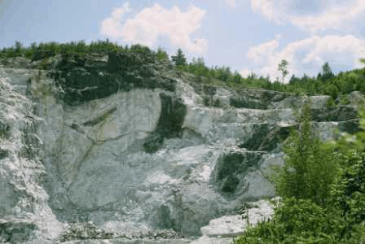
GRENVILLE MARBLES
Marbles are especially abundant in the Mont-Laurier terrain of the Grenville Province. They are the products of regional metamorphism and contact metasomatism acting on what were originally limestones. Compositionally, they range from nearly pure calcite, to marbles rich in calcium- and magnesium-bearing minerals such as diopside, wollastonite, meionite (scapolite), and spinel. Brucite has been mined near Wakefield as an ore of magnesium, and magnesite at Kilmar for the manufacture of refractories.

Below: Mattagami Lake mine.
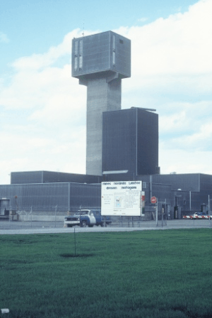
Caption: Headframe of the Mattagami Lake zinc mine. Photo: P. Tarassoff

[Jeanne, Quebec is misspelled in the text.]

MINERALS FROM THE ABITIBI
GEOLOGICAL SUBPROVINCE

Qu ec’s most important gold, copper and zinc mines are in the Abitibi Subprovince of the Superior Province. Copper and zinc are primarily mined from volcanogenic massive sulphide (VMS) deposits. The Mattagami Lake mine is the type locality for two telluride minerals, mattagamite and tellurantimony. Both occur as microscopic inclusions in altaite.

[Jeanne, “Saint-Honor” is misspelled in the title and text. It should be “Saint-Honore”. Re the caption, we must in any case credit Cambior.]

Caption: Niobec pyrochlore mine. Photo courtesy of Cambior Inc.

Below: Niobec mine. Not sure there’s room for any caption in that section, though.

NIOBEC MINE, SAINT-HONOR CARBONATITE COMPLEX
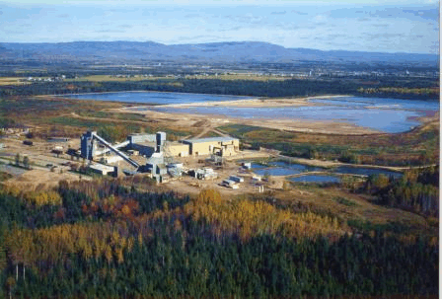

The Niobec mine is a major producer of ferroniobium which is used in the manufacture of steel. The niobium ore-mineral, pyrochlore, occurs in a carbonatite complex of late Proterozoic age. In contrast to the Oka carbonatite in the Monteregian Province, the primary carbonate mineral in the Saint-Honor carbonatite is dolomite rather than calcite. Large crystals of barite and calcite are found in solution cavities in an outlier of Ordovician-age limestone which overlies the carbonatite.

Below: phosphate mine, Grenville province.
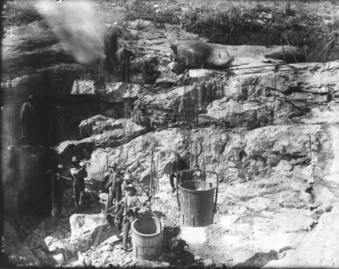
GRENVILLE PEGMATITES

Granitic pegmatites are common in the Grenville Province of both Quebec and Ontario. They tend to occur in belts of metamorphic rocks, and are rarely associated with granitic intrusions. This suggests that many are anatectic in origin: they formed by the melting of surrounding rocks.

Granitic pegmatites are classified according to their enrichment in certain elements, which is reflected in the accessory minerals they contain. Grenville pegmatites are predominantly of the NYF (niobium-yttrium-fluorine) type. Examples include the Villeneuve, Maisonneuve and Evans-Lou pegmatites represented by the mineral specimens shown here. The Leduc pegmatite is the only known example of a LCT (lithium-cesium-tantalum) pegmatite in the Grenville Province.

Left: VMS sulphides (will only be included if I finish cleaning it up…)
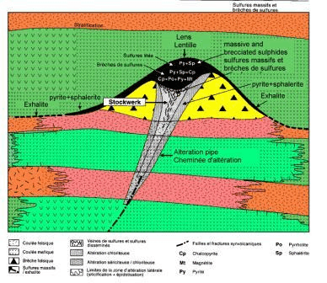

I’m not sure that we have printed a text yet specifically on this type of deposit.

